# **ETL and Data Pipelines with Shell, Airflow and Kafka**

[ETL and Data Pipelines with Shell, Airflow and Kafka - Data Processing Techniques - Week 1 | Coursera](https://www.coursera.org/learn/etl-and-data-pipelines-shell-airflow-kafka/home/module/1)

## Module 1

### Course Introduction

Are you an aspiring Big Data Engineer or Developer interested in creating Data Pipelines for serving Data Warehouses and Data Analytics platforms? Would you like to learn all about ETL and ELT data pipelines and how to build them using Bash scripting and cutting-edge open-source tools such as Apache Airflow and Apache Kafka? This course may be just right for you.

ETL stands for Extract, Transform, and Load. It refers to the process of curating data from multiple sources and preparing the data for integration and loading into a destination platform such as a data warehouse or analytics environment. ELT is similar but loads the data in its raw format, reserving the transformations for people to apply themselves in a ‘self-serve analytics’ destination environment. Both methods are typical examples of data pipeline deployments.

In this course, you will explore the fundamental principles and techniques behind ETL and ELT processes. You will learn how to construct a basic ETL data pipeline from scratch using Bash shell-scripting. You will also learn about the tools, technologies, and use cases for the two main paradigms within data pipeline engineering: batch and streaming data pipelines.  You will further cement this knowledge by exploring and applying two popular open-source data pipeline tools: Apache Airflow and Apache Kafka.

You will learn all about Apache Airflow and use it to build, put into production, and monitor a basic batch ETL workflow. You will implement this data pipeline using Airflow’s central construct of a directed acyclic graph (DAG), consisting of simple Bash tasks, Python function and their dependencies.

You will also learn about Apache Kafka and use it to get hands-on experience with streaming data pipelines, implementing Kafka’s message producers and consumers, and creating a Kafka weather topic.

This video and hands-on, lab-based course is made up of 5 modules: Data Processing Techniques; ETL & Data Pipelines: Tools and Techniques; Building Data Pipelines using Apache Airflow; Building Streaming Pipelines using Apache Kafka; and a Final Assignment. “ETL and Pipelines” will provide you with a great hands-on introduction to the latest technologies in data pipeline engineering.

### **ETL Fundamentals**

ETL is an automated data pipeline engineering methodology, whereby data is acquired and prepared for subsequent use in an analytics environment, such as a data warehouse or data mart.

ETL refers to the process of curating data from multiple sources, conforming it to a unified data format or structure, and then loading the transformed data into its new environment.

The extraction process obtains or reads the data from one or more sources. The transformation process wrangles the data into a format that is suitable for its destination and its intended use. The final loading process takes the transformed data and loads it into its new environment, ready for visualization, exploration, further transformation, and modeling.

The curated data may also be utilized to support automation and decision-making

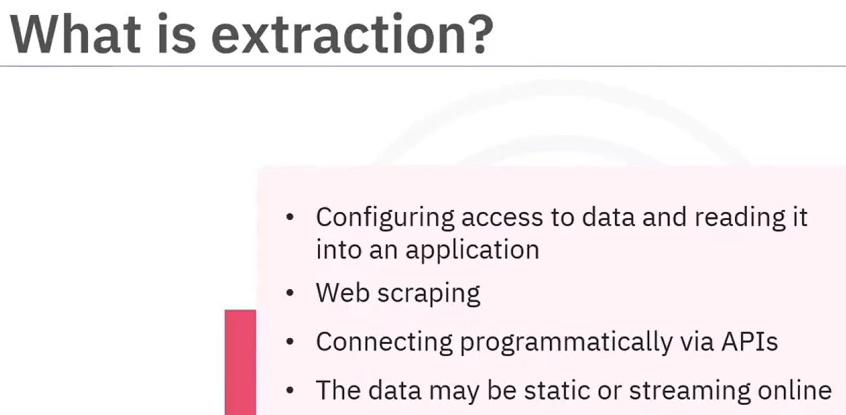

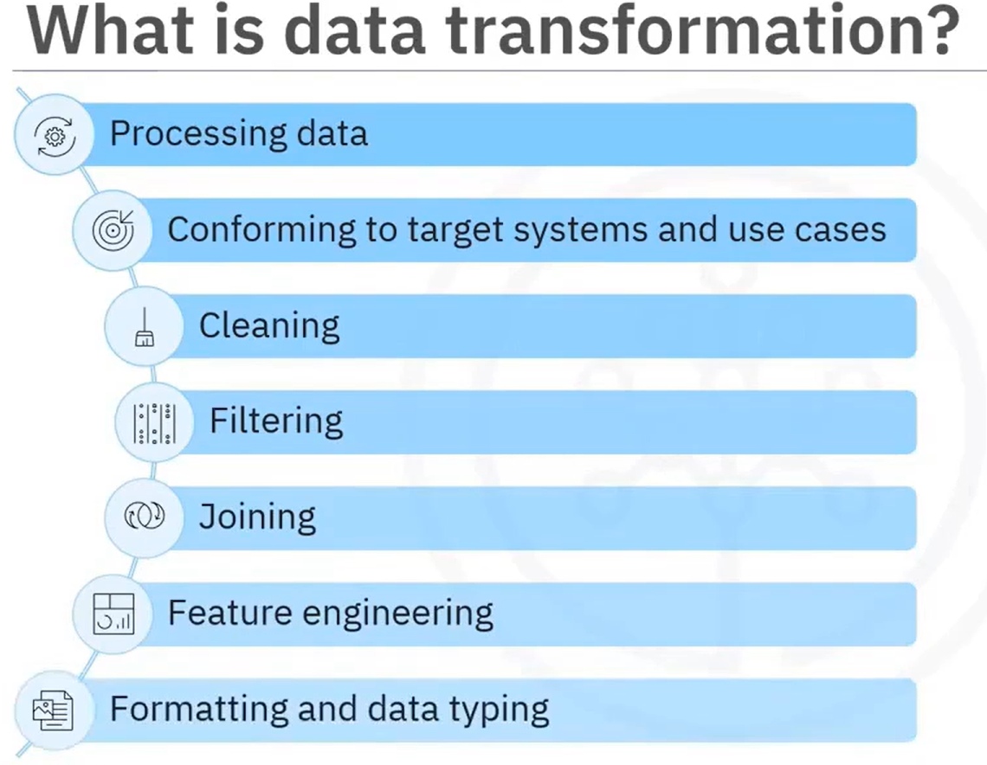 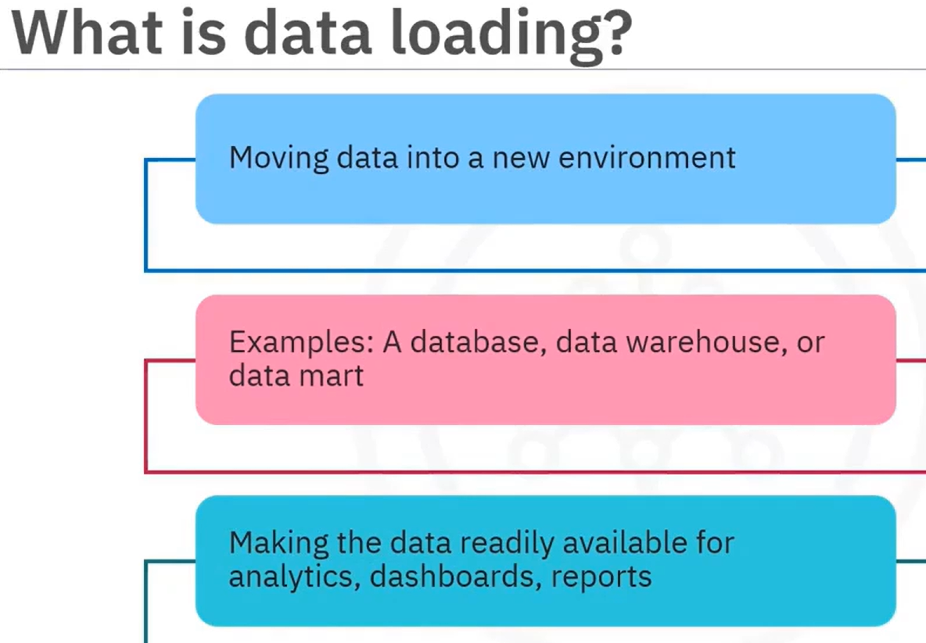

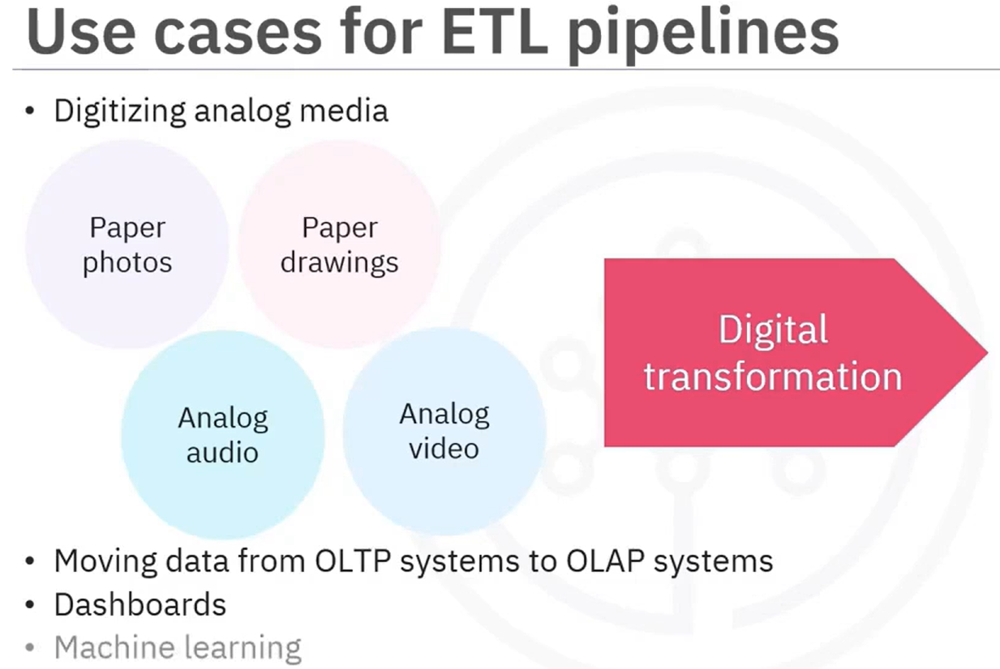 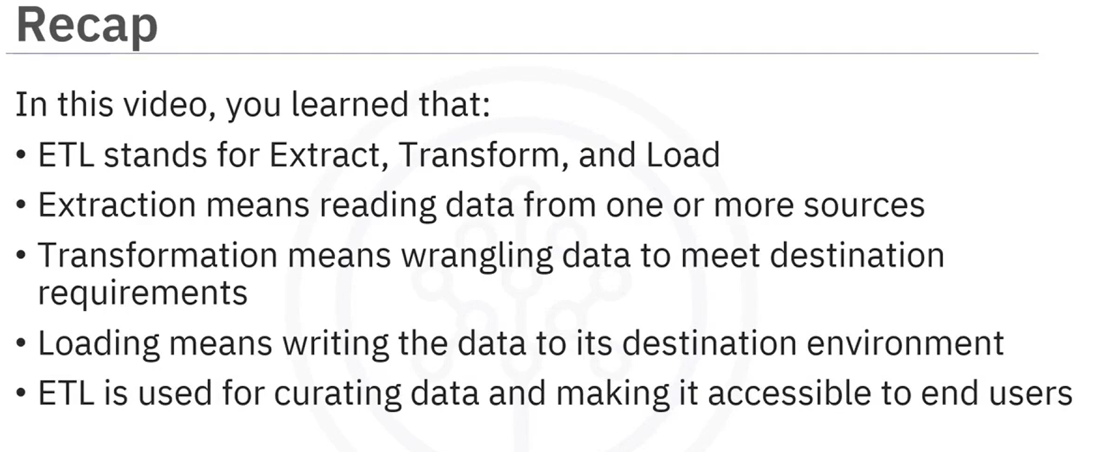

Online transaction processing (OLTP) systems don’t save historical data. Accordingly, ETL processes capture the transaction history and prepare it for subsequent analysis in an online analytical processing (OLAP) system.

### ELT Basics

The first stage in the ELT process is extraction.

The extraction process obtains the data from all sources and reads the data often in an asynchronous fashion into an application.

The loading process takes the raw data as is and loads it into its new environment where modern analytics tools can then be used directly.

The transformation process for ELT is much more dynamic than it is for conventional ETL.

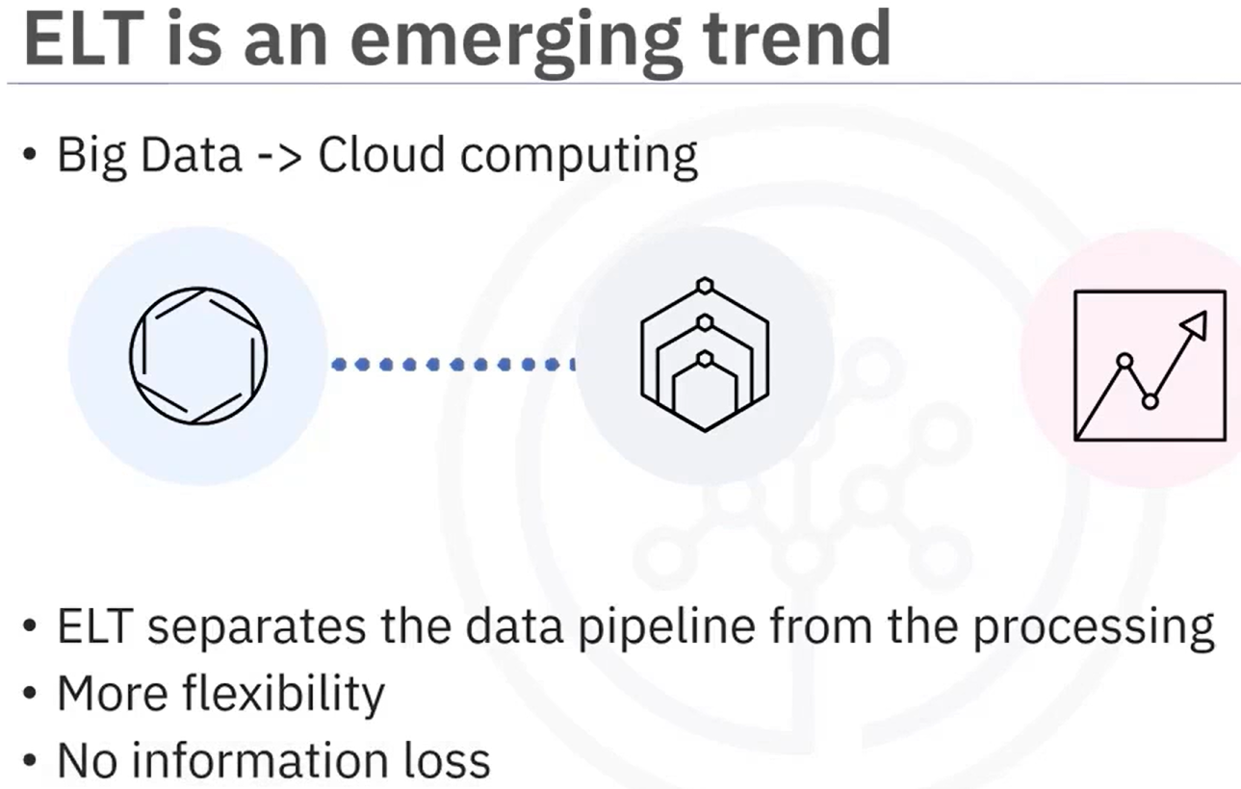

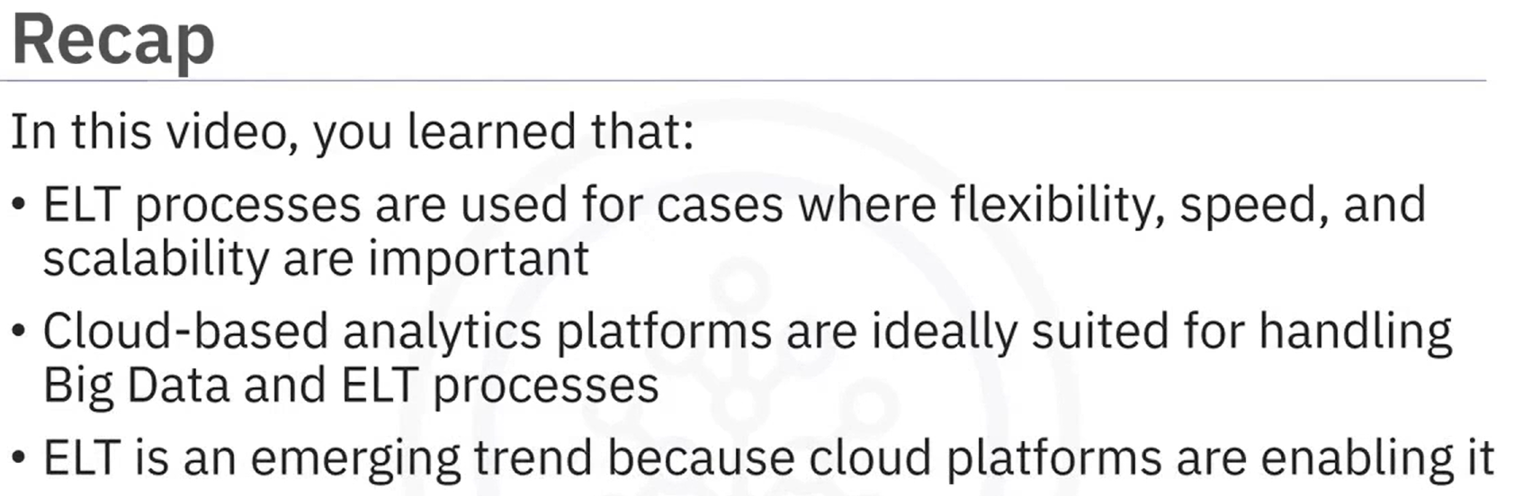

### **Comparing ETL and ELT**

Differences between ETL and ELT, for one thing, the transformations happen in a different order.

Transformations for ETL pipelines take place within the data pipeline before the data reaches its destination, whereas transformations for ELT are decoupled from the data pipeline and happen in the destination environment at will.

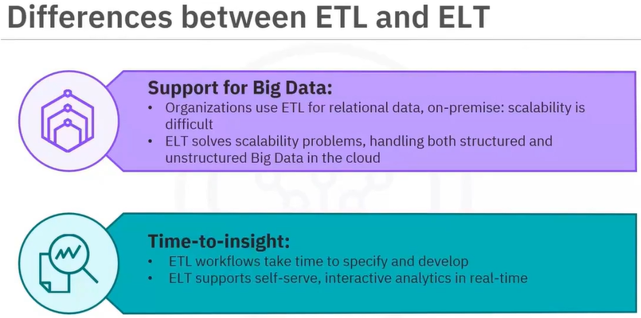

ETL pipelines take time and effort to modify, which means, users must wait for the development team to implement their requested changes.

ELT provides more agility with some training in modern analytics applications, end users can easily connect to and experiment with the raw data, create their own dashboards, and run predictive models themselves.

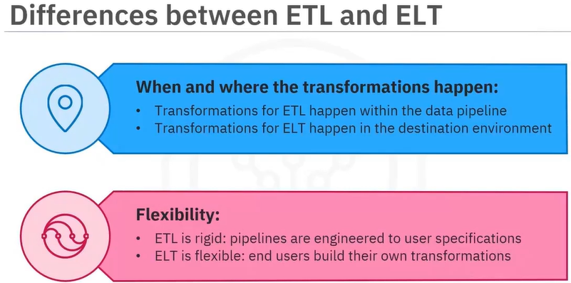

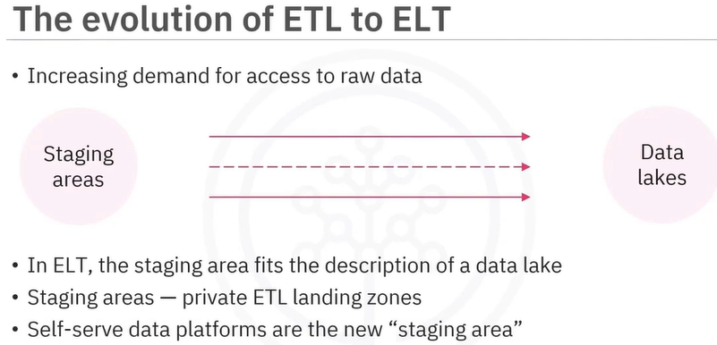

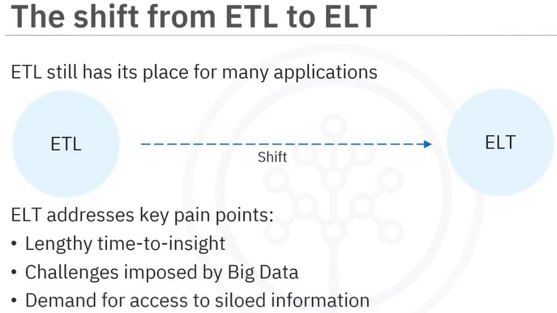

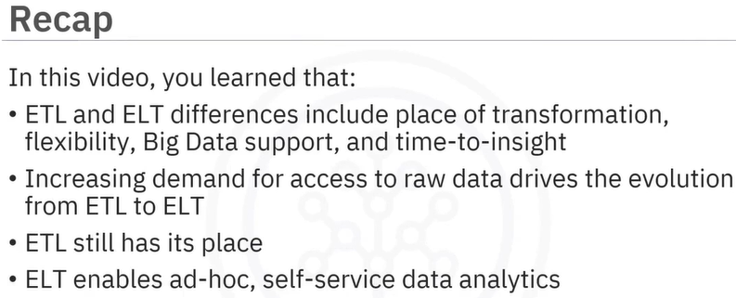

### Data extraction techniques

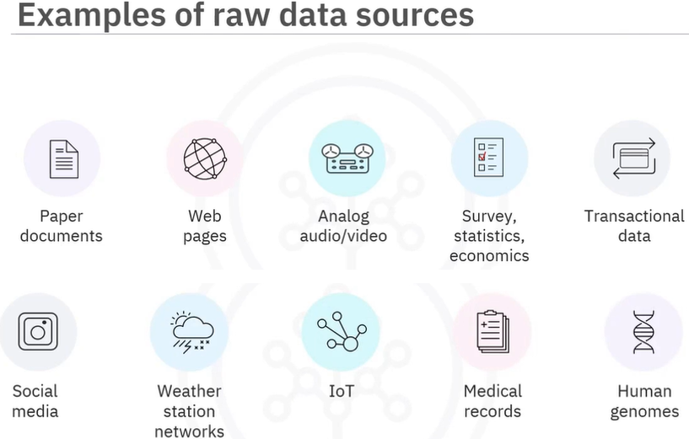

There are many techniques for extracting data, depending on the kind of data source and the intended use of the data. Examples include optical character recognition or OCR, which is used to interpret and digitize text scanned from paper documents so it can be stored as a computer readable file. Analog to digital converters or ADCs, which can digitize analog audio recordings and signals, and charge couple devices or CCDs that capture and digitize images. Opinions, questionnaires, and vital statistical data obtained through polling and Census methods. Cookies, user logs, and other methods used for tracking human or system behavior. More techniques include web scraping used to crawl web pages and search of text images, tables, and hyperlinks. APIs, which are readily available for extracting data from all online data repositories and feeds, such as government bureaus of statistics, libraries, weather networks, online shopping, and social networks. SQL languages for querying relational databases, and NoSQL for querying, document, key value, graph, or other non-structured data repositories. Edge computing devices, such as video cameras that have built-in processing that can extract features from raw data. Finally, biomedical devices, such as microfluidic arrays, that can extract DNA sequences.

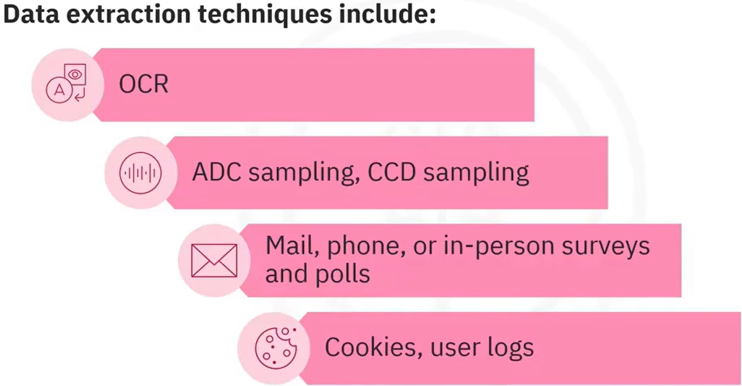 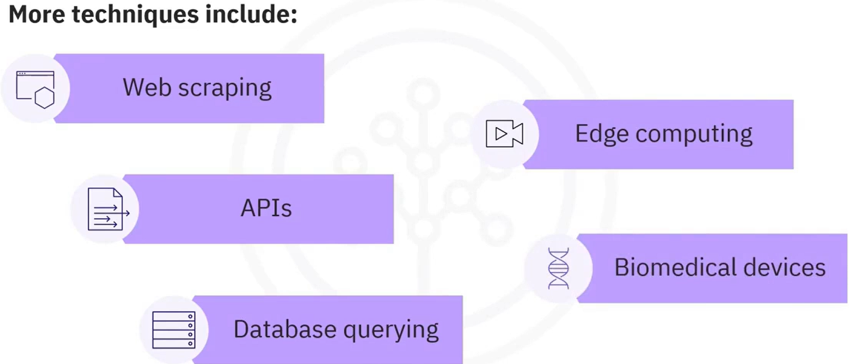

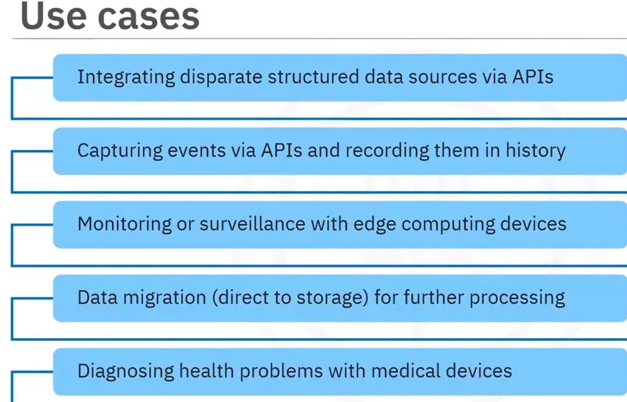

### Data transformation techniques

Data transformation is mainly about formatting the data to suit the application.

This can involve many kinds of operations, such as data typing, which involves casting data to appropriate types, such as integer, float, string, object, and category.

Data structuring, which includes converting one data format to another, such as JSON, XML, or CSV to database tables,   
Anonymizing and encrypting transformations to help ensure privacy and security.

Other types of transformations include cleaning operations for removing duplicate records, and filling missing values, normalizing data to ensure units are comparable, for example, using a common currency, filtering, sorting, aggregating, and binning operations for accessing the right data at a suitable level of detail and in a sensible order, and joining or merging disparate data sources.

**Schema-on-write versus schema-on-read**

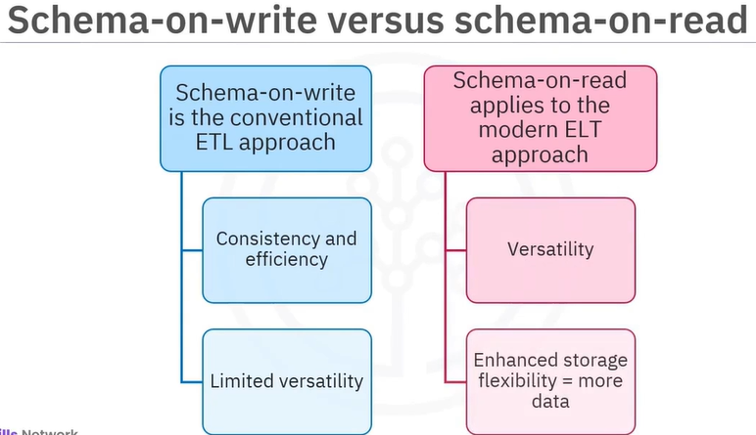

Whether intentional or accidental, there are many ways in which information can be lost in transformation. We can visualize this loss as follows: Raw data is normally much bigger than transformed data. Since data usually contains noise and redundancy.

For ETL processes, any lost information may or may not be recoverable, whereas with ELT, all the original information content is left intact because the data is simply copied over as is.

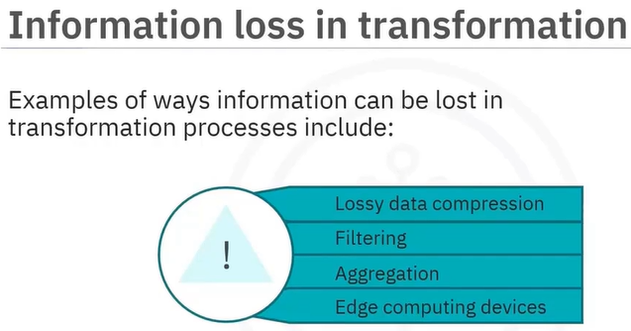 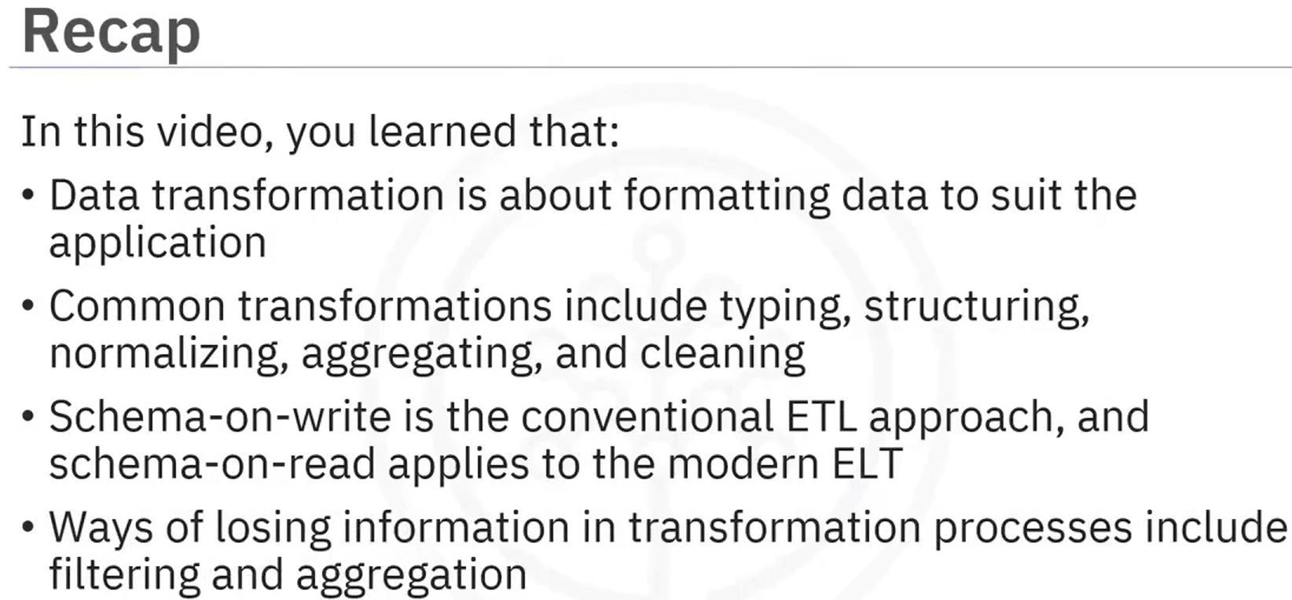

### **Data Loading Techniques**

There are two main data loading strategies, full loading and incremental loading. Full loading is used when you want to start tracking transactions in a new data warehouse or when you want to load an initial history into a database. To reiterate, there is no existing content when you use full loading. After full loading is complete, you can use incremental loading to insert data that has changed since the previous loading. With incremental loading strategy, data is appended in the database and not overwritten.

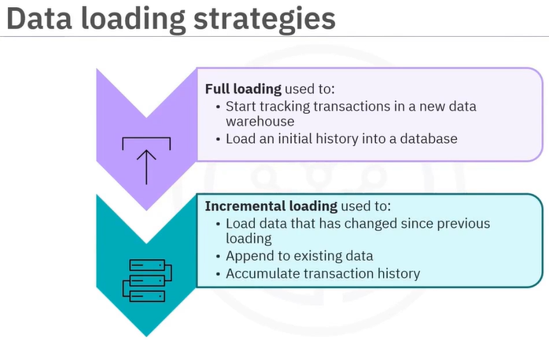 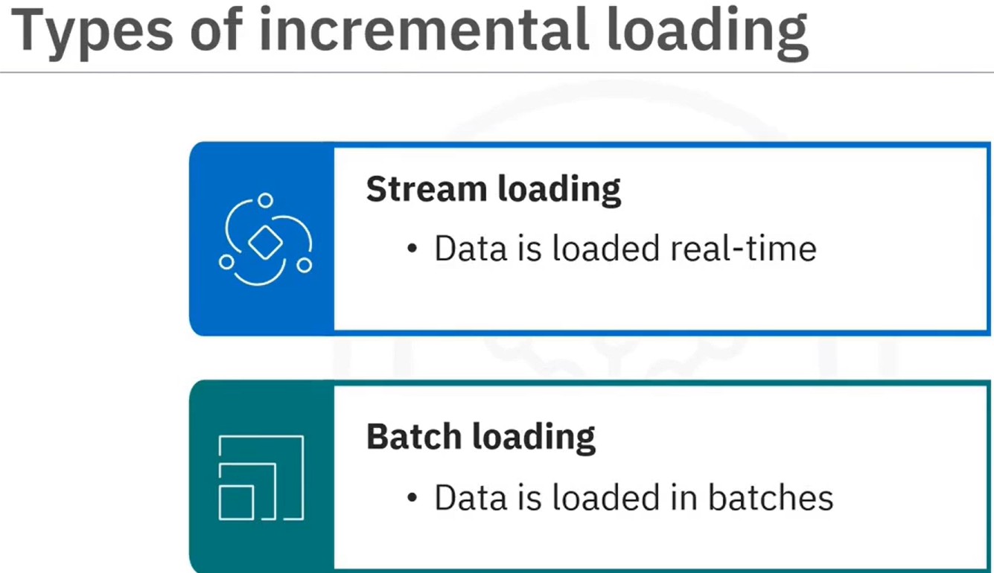

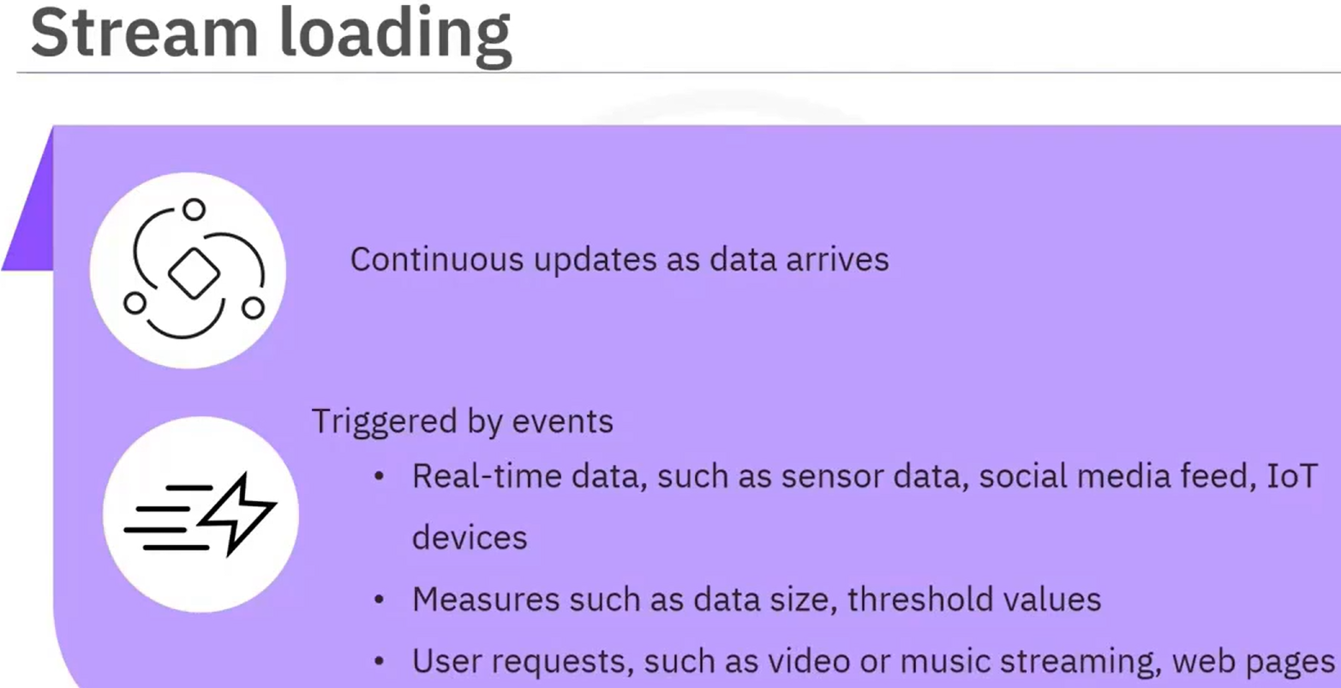 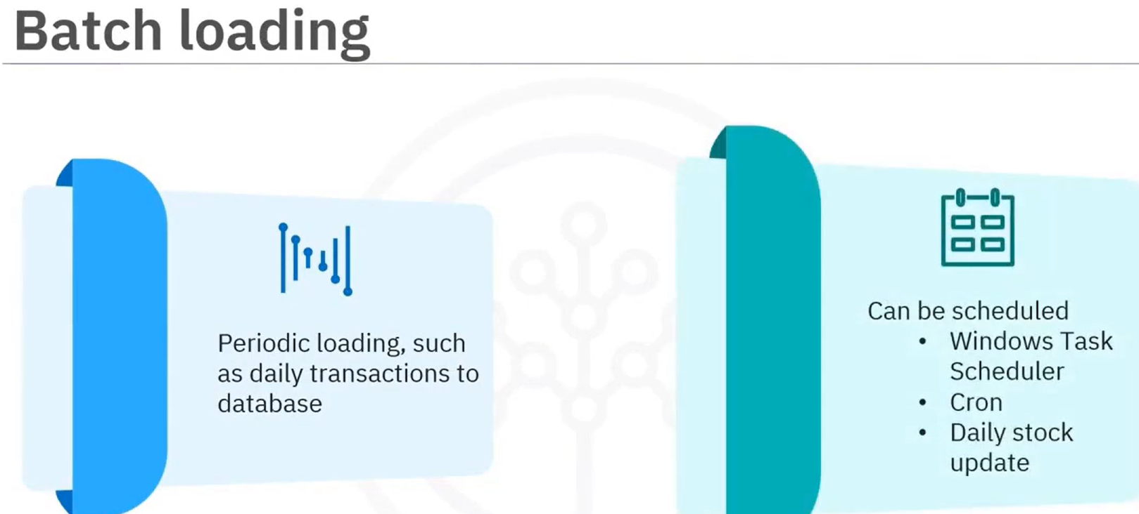

Stream loading refers to continuous data updates performed in the data warehouse or other storage systems as new data arrives. It is usually triggered by events, such as real-time data from sensors, like thermostat or motion sensors, social media feed, and IoT devices, and measures, such as data size when a certain amount of data is collected, or threshold values, or when a user requests data, such as online videos, music, or web pages. Batch loading refers to periodic updates made/pushed to the data in the data warehouse or other storage systems, such as daily updates, hourly updates, or weekly updates. Batch data can be scheduled.

Push and pull data loading methodologies are based on a client-server or publisher-subscriber model. A push method is used when the source pushes data into the data warehouse or other storage. While push method can be used for batch loading, it is most suited for stream loading involving real-time data. A pull method is used when the data warehouse pulls the data from the source by subscribing to receive the data. It is useful for scheduled transactions and batch loading. Loading can be serial or parallel. Serial loading is when the data is copied sequentially, one after the other. This is how data loads in the data warehouse by default. You can use parallel loading when you need to load data from different sources parallelly or to split data from one source into chunks and load them parallelly. When compared with serial loading, parallel loading is a faster and optimized approach.

Data can be loaded in batches, or it can be streamed continuously into its destination.

Both pull and push methodologies can be used for data loading, and you can employ parallel loading to boost loading efficiency of large volumes of data.

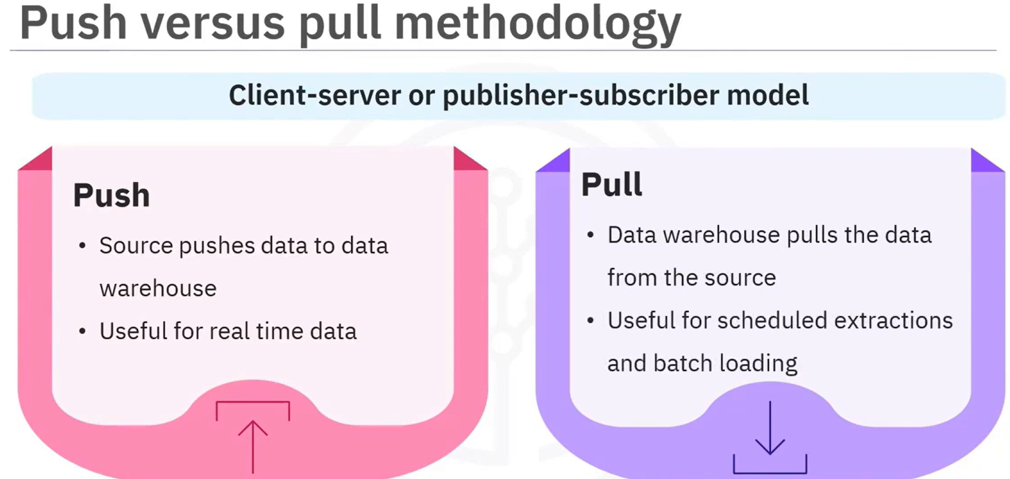

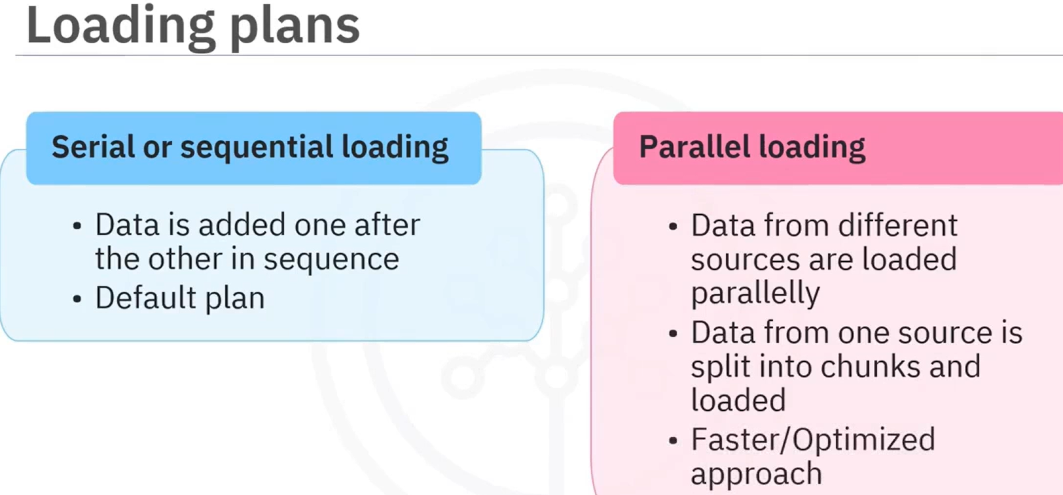

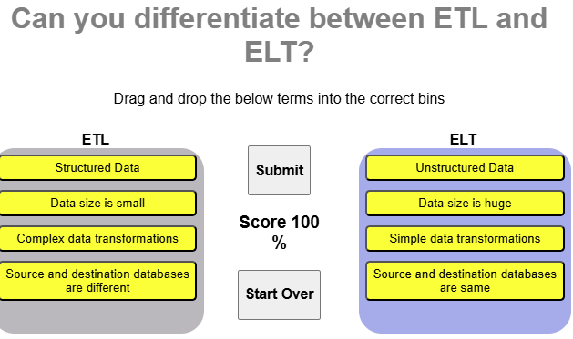

### Summary & Highlights

Congratulations! You have completed this module. At this point, you know:

* ETL stands for Extract, Transform, and Load
* Loading means writing the data to its destination environment
* Cloud platforms are enabling ELT to become an emerging trend
* The key differences between ETL and ELT include the place of transformation, flexibility, Big Data support, and time-to-insight
* There is an increasing demand for access to raw data that drives the evolution from ETL, which is still used, to ELT, which enables ad-hoc, self-serve analytics
* Data extraction often involves advanced technology including database querying, web scraping, and APIs
* Data transformation, such as typing, structuring, normalizing, aggregating, and cleaning, is about formatting data to suit the application
* Information can be lost in transformation processes through filtering and aggregation
* Data loading techniques include scheduled, on-demand, and incremental
* Data can be loaded in batches or streamed continuously

### Practice assignment ETL and ELT Processes

**Question 1. ETL process consists of Extract > Transform > Load. Which of these three processes is also known as data wrangling?**

Data wrangling is a term for another data warehouse process

Transform

Extraction

Load

**Question 2. What is the main difference between the ELT and ETL process?**

ETL used primarily for cloud

ELT is only used for analyzing

Order of stages

Data types

**Question 3. Transformations for ETL happen in the data pipeline. Where do transformations happen for ELT?**

Extraction process

Destination environment

Source environment

Load process

**Question 4. Which of the following raw data sources is related to sales?**

Merchandise data

Analog data

Survey data

Transactional data (Transactional data from business, financial, real estate, and point-of sale (POS) transactions)

**Question 5. Which of the following data transformation techniques will be suitable for ‘unlike’ data sources?**

Joining or merging (This technique addresses disparate data sources.)

Filtering, sorting, aggregation

Data structuring

Cleaning

### Graded Quiz: ETL and ELT Processes

**Question 1. ETL process consists of Extract > Transform > Load. Which of the three processes is also known as data wrangling?**

Extraction

Transform

Data wrangling is a term for another data warehouse process.

Load

**Question 2. The ELT process has no information loss. What is the main reason for this benefit?**

There is a separation between moving and processing data.

Data is acquired and directly loaded, as-is, into its destination environment.

It separates the data pipeline from processing.

Data source integration

**Question 3. Which of the following in an ELT process best compares to the “Staging area” in the ETL process?**

Data lake in ELT process (The staging area fits the description of a data lake, which is a modern self-serve repository for storing and manipulating raw data)

Database servers

Storage for source data in the ELT process

Transformed data storage

**Question 4. Which of the following pain points does ELT address?**

Request for fixed processes

Cost-effectiveness

Challenges imposed by Big Data

Transformation in data pipeline

**Question 5. There are many techniques for extracting data. What does the choice of technique depend on?**

Type of client

Optical or analog

Operating system

Kind of data source and intended use

**Question 6. Extracting data from IoT devices involves large volumes of redundant data. What is used to decrease the data volume of redundant data and only extract features of interest from raw data?**

Biometric sensors

Edge computing

APIs

SQL languages

**Correct**

Correct! Edge computing reduces the data volumes of redundant data by extracting features of interest from the raw data.

**Question 7. ETL uses the schema-on-write approach. What is the biggest disadvantage of this approach?**

Limited versatility

Consistency

Stability

More data access

**Correct**

Correct! The ETL approach limits the versatility whereas the ELT approach is versatile since it obtains multiple views of the same source data with ad-hoc schemas.

**Question 8. Why is there no information loss in ELT unlike ETL where there is loss of information?**

Because the data is copied as is

Because ELT uses edge computing

Because ETL uses aggregation of data but ELT doesn’t

Because ELT involves lossy data compression

**Question 9. Which of these is most useful for incremental loading strategy?**

File partitioning

Both batch and stream loading

Only stream loading

Only batch loading

**Correct**

Correct! Stream loading is useful for incremental loading and should be real-time. Batch loading is useful when the incremental loading can be in batches.

**Question 10. Which of the following loading techniques can split a single file into smaller chunks?**

Stream loading

Scheduled loading

Batch loading

Parallel loading

## Module 2. ETL using Shell Scripts

**Linux Commands and Shell Scripting**

A shell is a powerful user interface for Unix-like operating systems. It can interpret commands and run other programs. It also enables access to files, utilities, and applications, and is an interactive scripting language. Additionally, you can use a shell to automate tasks. Linux shell commands are used for navigating and working with files and directories. You can also use them for file compression and archiving.

**1. Características de los comandos de Linux y scripting en Shell**

* **Comandos de Linux**: Son instrucciones que se escriben en la terminal para realizar tareas como listar archivos (ls), copiar (cp), mover (mv), buscar (grep), etc.
* **Shell scripting**: Escribir scripts (archivos .sh) que contienen una secuencia de comandos. Esto permite **automatizar tareas** repetitivas.
* Características clave:
  + Basado en texto
  + Muy flexible y potente
  + Puede combinar múltiples comandos
  + Soporta condicionales, bucles, funciones, etc.

**📄 2. Diferentes comandos de Linux y sus salidas**

Aquí algunos comandos comunes y lo que devuelven:

| **Comando** | **Descripción** | **Salida típica** |
| --- | --- | --- |
| ls | Lista archivos y carpetas | Nombres de archivos y carpetas |
| pwd | Muestra el directorio actual | Ruta completa del directorio actual |
| cat archivo | Muestra el contenido de un archivo | Texto dentro del archivo |
| ps | Lista procesos en ejecución | IDs de procesos, nombres, estados |
| df -h | Uso del disco en formato legible | Espacio usado y libre por partición |

**⏰ 3. Cómo programar tareas usando crontab**

* **crontab** permite **programar tareas automáticas** (cron jobs), como ejecutar scripts o comandos en momentos específicos.

**Ejemplo:**

crontab -e

Luego agregas una línea como:

0 6 * * * /home/user/script.sh

Esto ejecuta script.sh todos los días a las **6:00 a.m.**

**Formato:**

minuto hora día_del_mes mes día_de_la_semana comando

**4. Cómo trabajar con filtros, pipes y variables**

* **Filtros**: Comandos como grep, awk, sed que procesan texto y filtran resultados.
  + Ej: grep "error" log.txt — muestra líneas que contienen "error".
* **Pipes (|)**: Permiten **encadenar comandos**, donde la salida de uno es la entrada de otro.
  + Ej: cat archivo.txt | grep "clave" — busca una palabra clave dentro del archivo.
* **Variables**: Se usan para almacenar valores en scripts.

nombre="Ana"

echo "Hola, $nombre"

### ETL Techniques

ETL stands for Extract, Transform, and Load, and refers to the process of curating data from multiple sources, conforming it to a unified data format or structure, and loading the transformed data into its new environment.

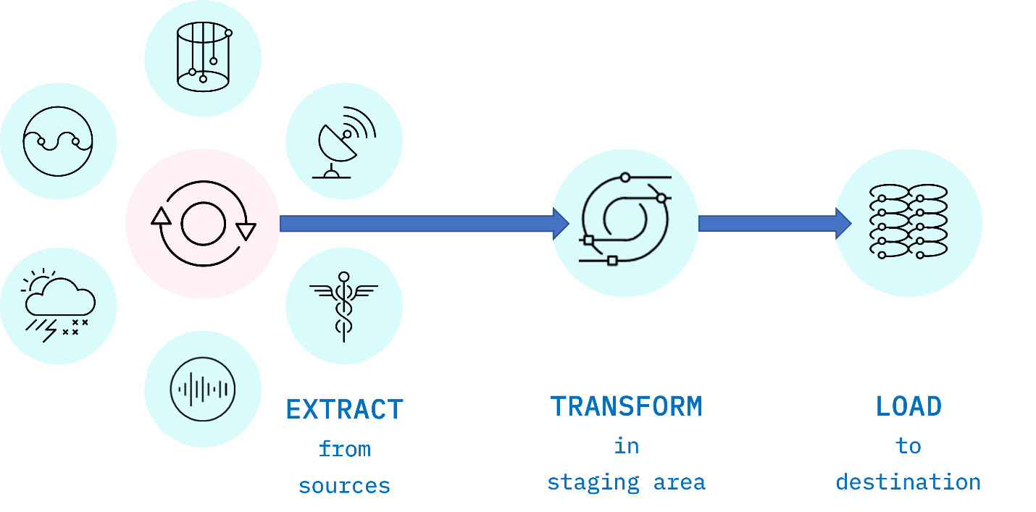

*Fig. 1. ETL is an acronym used to describe the main processes behind a data pipeline design methodology that stands for Extract-Transform-Load. Data is extracted from disparate sources to an intermediate staging area where it is integrated and prepared for loading into a destination such as a data warehouse.*

**Extract**

Data extraction is the first stage of the ETL process, where data is acquired from various source systems. The data may be completely raw, such as sensor data from IoT devices, or perhaps it is unstructured data from scanned medical documents or company emails. It may be streaming data coming from a social media network or near real-time stock market buy/sell transactions, or it may come from existing enterprise databases and data warehouses.

**Transform**

The transformation stage is where rules and processes are applied to the data to prepare it for loading into the target system. This is normally done in an intermediate working environment called a “staging area.” Here, the data are cleaned to ensure reliability and conformed to ensure compatibility with the target system.

Many other transformations may be applied, including:

* Cleaning: fixing any errors or missing values
* Filtering: selecting only what is needed
* Joining: merging disparate data sources
* Normalizing: converting data to common units
* Data Structuring: converting one data format to another, such as JSON, XML, or CSV to database tables
* Feature Engineering: creating KPIs for dashboards or machine learning
* Anonymizing and Encrypting: ensuring privacy and security
* Sorting: ordering the data to improve search performance
* Aggregating: summarizing granular data

**Load**

The load phase is all about writing the transformed data to a target system. The system can be as simple as a comma-separated file, which is essentially just a table of data like an Excel spreadsheet. The target can also be a database, which may be part of a much more elaborate system, such as a data warehouse, a data mart, data lake, or some other unified, centralized data store forming the basis for analysis, modeling, and data-driven decision making by business analysts, managers, executives, data scientists, and users at all levels of the enterprise.

In most cases, as data is being loaded into a database, the constraints defined by its schema must be satisfied for the workflow to run successfully. The schema, a set of rules called integrity constraints, includes rules such as uniqueness, [referential integrity](https://en.wikipedia.org/wiki/Referential_integrity), and mandatory fields. Thus such requirements imposed on the loading phase help ensure overall data quality.

**ETL Workflows as Data Pipelines**

Generally, an ETL workflow is a well thought out process that is carefully engineered to meet technical and end-user requirements.

Traditionally, the overall accuracy of the ETL workflow has been a more important requirement than speed, although efficiency is usually an important factor in minimizing resource costs. To boost efficiency, data is fed through a *data pipeline* in smaller packets (see Figure 2). While one packet is being extracted, an earlier packet is being transformed, and another is being loaded. In this way, data can keep moving through the workflow without interruption. Any remaining bottlenecks within the pipeline can often be handled by parallelizing slower tasks.

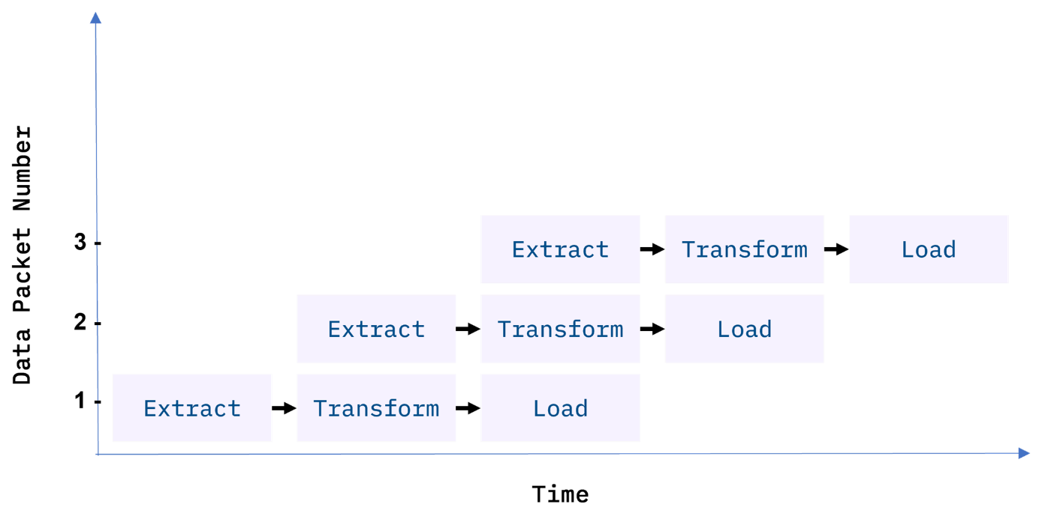

*Fig 2. Data packets being fed in sequence, or “piped” through the ETL data pipeline. Ideally, by the time the third packet is ingested, all three ETL processes are running simultaneously on different packets.*

With conventional ETL pipelines, data is processed in *batches*, usually on a repeating schedule that ranges from hours to days apart. For example, records accumulating in an Online Transaction Processing System (OLTP) can be moved as a daily batch process to one or more Online Analytics Processing (OLAP) systems where subsequent analysis of large volumes of historical data is carried out.

Batch processing intervals need not be periodic and can be triggered by events, such as

* when the source data reaches a certain size, or
* when an event of interest occurs and is detected by a system, such as an intruder alert, or
* on-demand, with web apps such as music or video streaming services

**Staging Areas**

ETL pipelines are frequently used to integrate data from disparate and usually siloed systems within the enterprise. These systems can be from different vendors, locations, and divisions of the company, which can add significant operational complexity. As an example, (see Figure 3) a cost accounting OLAP system might retrieve data from distinct OLTP systems utilized by the separate payroll, sales, and purchasing departments.

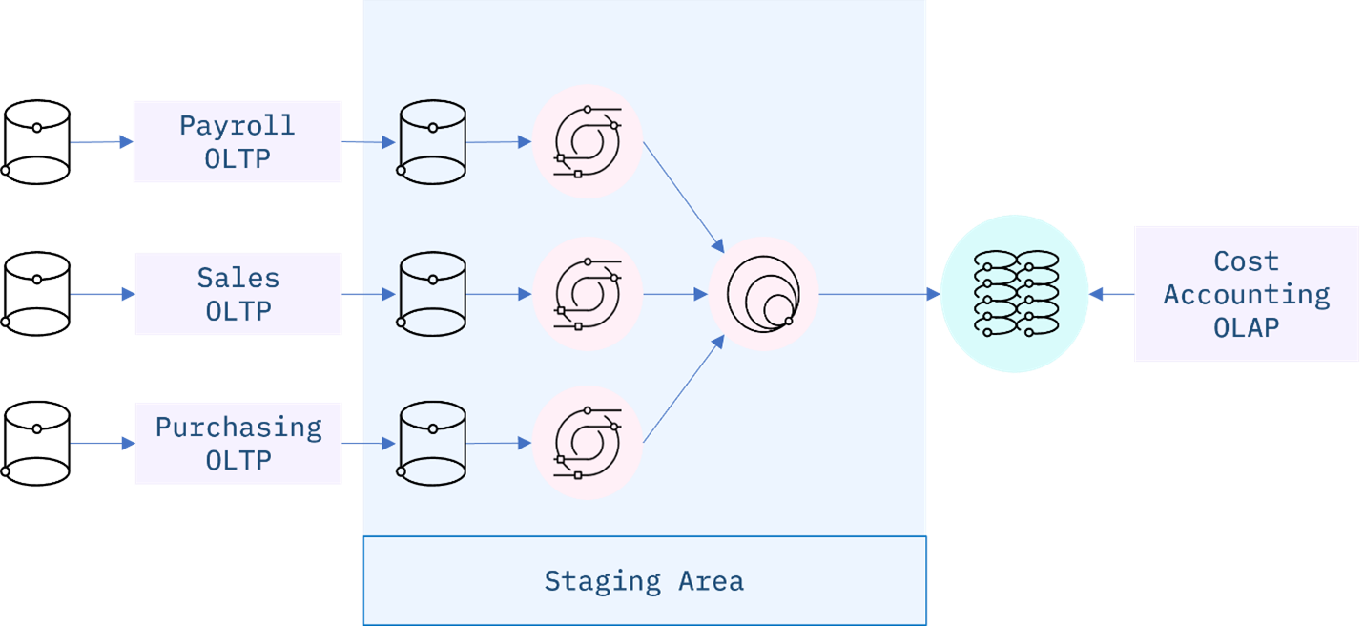

*Fig 3. An ETL data integration pipeline concept for a Cost Accounting OLAP, fed by disparate OLTP systems within the enterprise. The staging area is used in this example to manage change detection of new or modified data from the source systems, data updates, and any transformations required to conform and integrate the data prior to loading to the OLAP.*

**ETL Workflows as DAGs**

ETL workflows can involve considerable complexity. By breaking down the details of the workflow into individual tasks and dependencies between those tasks, one can gain better control over that complexity. Workflow orchestration tools such as Apache Airflow do just that.

Airflow represents your workflow as a directed acyclic graph (DAG). A simple example of an Airflow DAG is illustrated in Figure 4. Airflow tasks can be expressed using predefined templates, called operators. Popular operators include Bash operators, for running Bash code, and Python operators for running Python code, which makes them extremely versatile for deploying ETL pipelines and many other kinds of workflows into production.

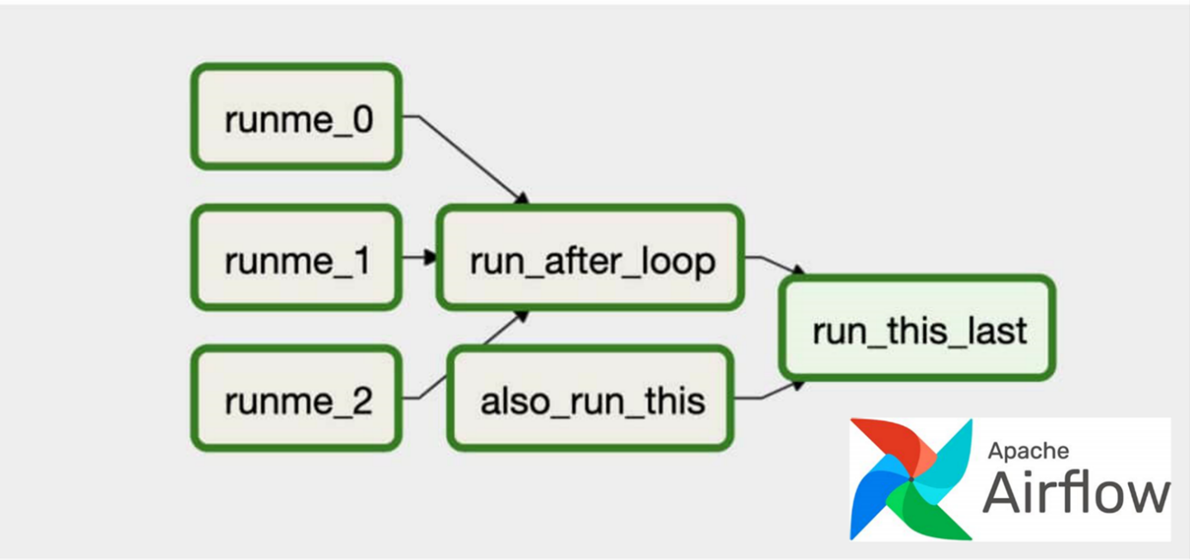

*Fig 4. An Apache Airflow DAG representing a workflow. The green boxes represent individual tasks, while the arrows show dependencies between tasks. The three tasks on the left, ‘runme_j’ are jobs that run simultaneously along with the ‘also_run_this’ task. Once the ‘runme_j’ tasks complete, the ‘run_after_loop’ task starts. Finally, ‘run_this_last’ engages once all tasks have finished successfully.*

**Popular ETL tools**

There are many ETL tools available today. Modern enterprise grade ETL tools will typically include the following features:

* Automation: Fully automated pipelines
* Ease of use: ETL rule recommendations
* Drag-and-drop interface: “o-code” rules and data flows
* Transformation support: Assistance with complex calculations
* Security and Compliance: Data encryption and HIPAA, GDPR compliance

Some well-known ETL tools are listed below, along with some of their key features. Both commercial and open-source tools are included in the list.

**Talend Open Studio**

* Supports big data, data warehousing, and profiling
* Includes collaboration, monitoring, and scheduling
* Drag-and-drop GUI for ETL pipeline creation
* Automatically generates Java code
* Integrates with many data warehouses
* Open-source

**AWS Glue**

* ETL service that simplifies data prep for analytics
* Suggests schemas for storing your data
* Create ETL jobs from the AWS Console

**IBM InfoSphere DataStage**

* A data integration tool for designing, developing, and running ETL and ELT jobs
* The data integration component of IBM InfoSphere Information Server
* Drag-and-drop graphical interface
* Uses parallel processing and enterprise connectivity in a highly scalable platform

**Alteryx**

* Self-service data analytics platform
* Drag-and-drop accessibility to ETL tools
* No SQL or coding required to create pipelines

**Apache Airflow and Python**

* Versatile “configuration” as code data pipeline platform
* Open-sourced by Airbnb
* Programmatically author, schedule, and monitor workflows
* Scales to Big Data
* Integrates with cloud platforms

**The Pandas Python library**

* Versatile and popular open-source programming tool
* Based on data frames – table-like structures
* Great for ETL, data exploration, and prototyping
* Doesn’t readily scale to Big Data

**📊 Comparación rápida:**

| **Característica** | **Data Warehouse** | **Data Mart** | **Data Lake** |
| --- | --- | --- | --- |
| Tipo de datos | Estructurados | Estructurados | Todo tipo (raw data) |
| Tamaño | Grande | Más pequeño | Muy grande |
| Audiencia | Nivel organizacional | Nivel departamental | Científicos/analistas de datos |
| Transformación | Antes de cargar (ETL) | Antes de cargar (ETL) | Después de cargar (ELT) |
| Velocidad de acceso | Alta (para análisis) | Más rápida (segmentada) | Varía (depende del procesamiento) |

### ETL Using Shell Scripting - Example

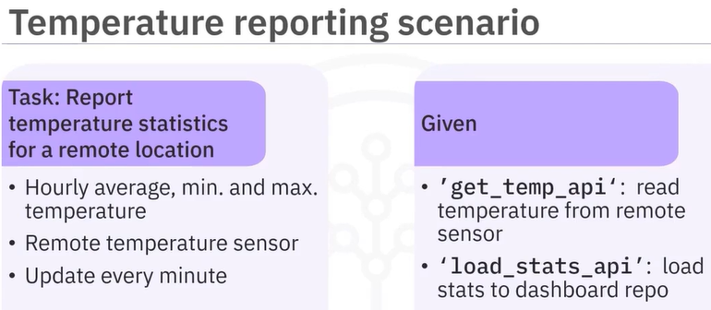

Program it to be executed each minute:  
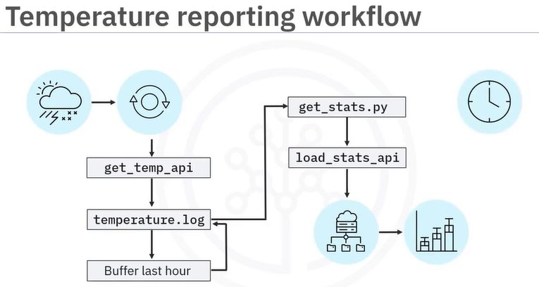

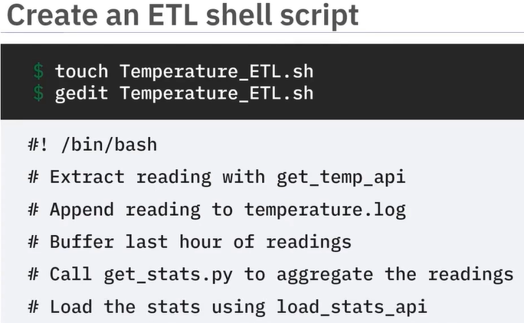

Extract data:  
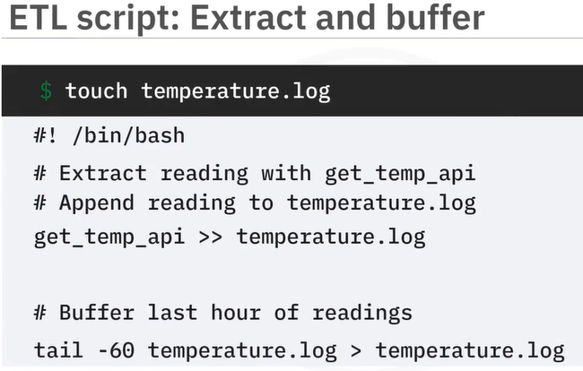

Transform data:

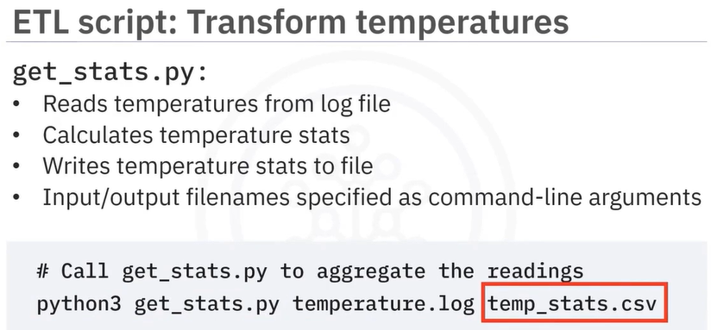

Load transformed data:

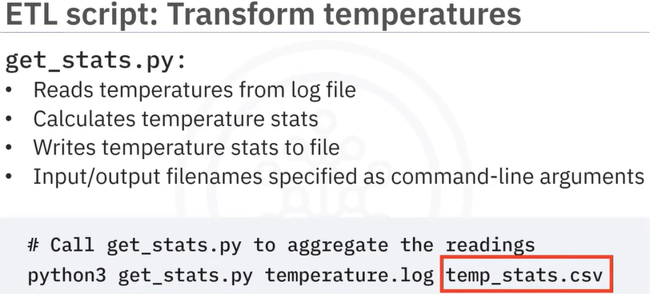

Load data:

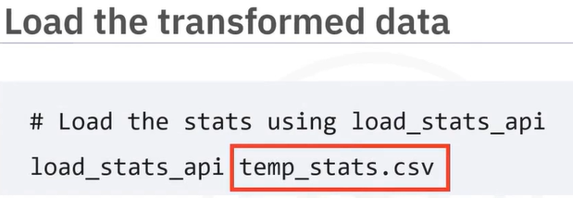

Schedule job:

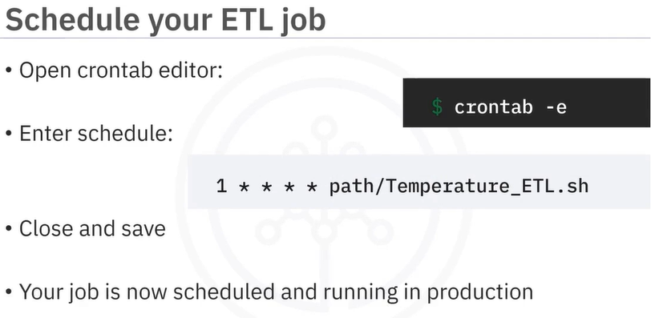

### Hands-On Lab: ETL using Shell Scripts

**Getting the environment ready**

Open a new terminal, by clicking on the menu bar and selecting **Terminal**->**New Terminal**, as in the image below. This will open a new terminal at the bottom of the screen.

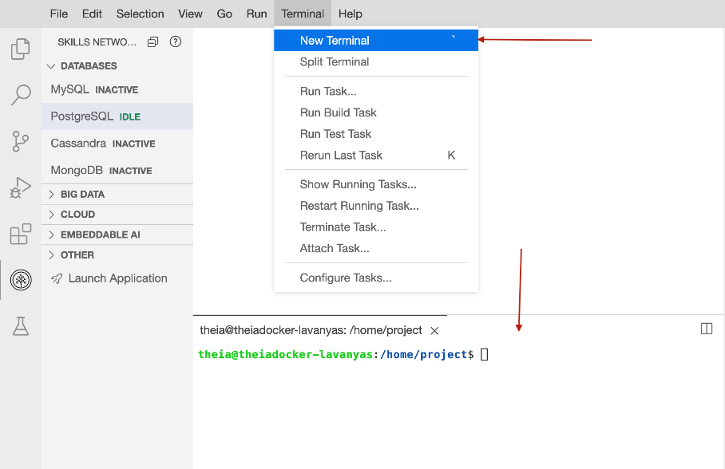

### **Exercise 1 - Extracting data using 'cut' command**

**✂️ cut – Comando para extraer texto**

cut se utiliza para **extraer caracteres o campos** específicos de líneas de texto o archivos.

**🧾 1. Extracción de caracteres (por posición)**

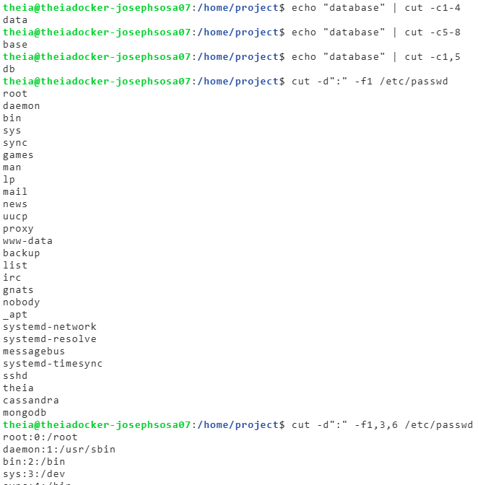**🔹 Extraer del 1º al 4º carácter:**

echo "database" | cut -c1-4

# Resultado: data

**🔹 Extraer del 5º al 8º carácter:**

echo "database" | cut -c5-8

# Resultado: base

**🔹 Extraer caracteres no contiguos (1º y 5º):**

echo "database" | cut -c1,5

# Resultado: db

**📊 2. Extracción de campos (por delimitador y posición)**

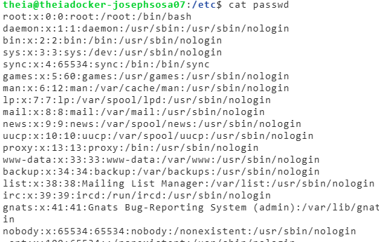

Usamos:

* -d para especificar el **delimitador** (ej. : o ,)
* -f para indicar el **número de campo(s)** a extraer

**🔹 Extraer el primer campo (username) del archivo /etc/passwd:**

cut -d":" -f1 /etc/passwd

Muestra todos los nombres de usuario del sistema.

**🔹 Extraer múltiples campos (1º, 3º y 6º):**

cut -d":" -f1,3,6 /etc/passwd

Muestra: username, userid, and home directory.

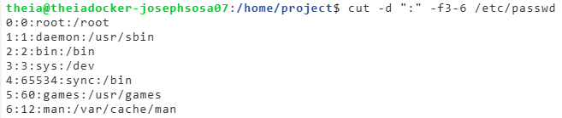**🔹 Extraer un rango de campos (del 3º al 6º):**

cut -d":" -f3-6 /etc/passwd

Muestra: userid, groupid, user description and home directory.

**🧠 Consejo útil:**

* cut es muy eficiente y rápido, ideal para archivos delimitados simples.
* Para procesamiento más complejo (condiciones, expresiones regulares), puedes usar awk.

### **Exercise 2 - Transforming data using 'tr'**

tr is a filter command used to translate, squeeze (**Eliminar caracteres repetidos consecutivos**, dejando solo uno), and/or delete characters.

1. Translate from one character set to another

The command below translates all lower case alphabets to upper case.

echo "Shell Scripting" | tr "[a-z]" "[A-Z]"

You could also use the pre-defined character sets also for this purpose:

echo "Shell Scripting" | tr "[:lower:]" "[:upper:]"

The command below translates all upper case alphabets to lower case.

echo "Shell Scripting" | tr "[A-Z]" "[a-z]"

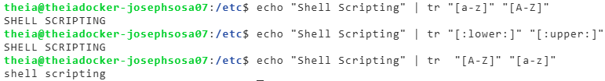

1. Squeeze repeating occurrences of characters

The -s option replaces a sequence of a repeated characters with a single occurrence of that character.

The command below replaces repeat occurrences of ‘space’ in the output of ps command with one ‘space’.

ps | tr -s " "

In the above example, the space character within quotes can be replaced with the following: "[\:space\:]".

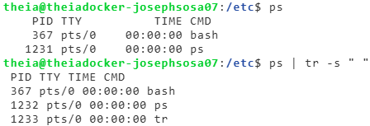

1. Delete characters

We can delete specified characters using the -d  option.

The command below deletes all digits.

echo "My login pin is 5634" | tr -d "[:digit:]"

The output will be: ‘My login pin is’



### **Exercise 3 - Start the PostgreSQL database.**

1. From the SkillsNetwork tools, under Databases choose PostgresSQL Database server and click Start to start the server. This will take a few mins.

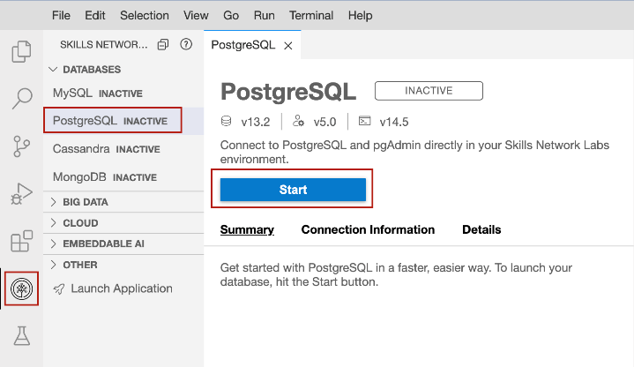

1. Click PostgresSQL CLI on the screen to start interacting wit the PostgresSQL server.

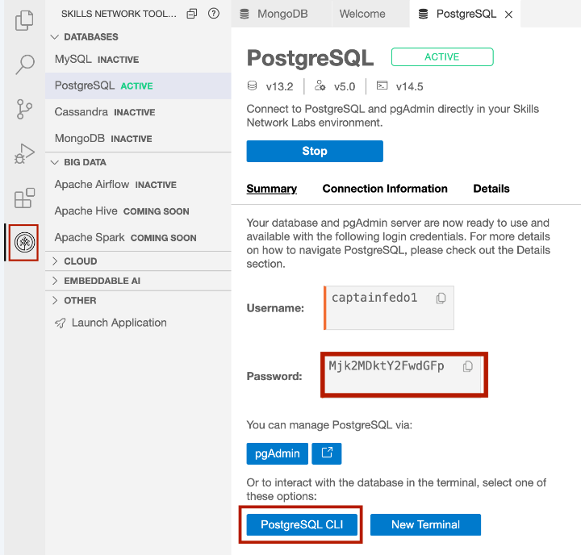

This will start the interactive psql client which connects to the PostgreSQL server with postgres=# prompt as shown below.

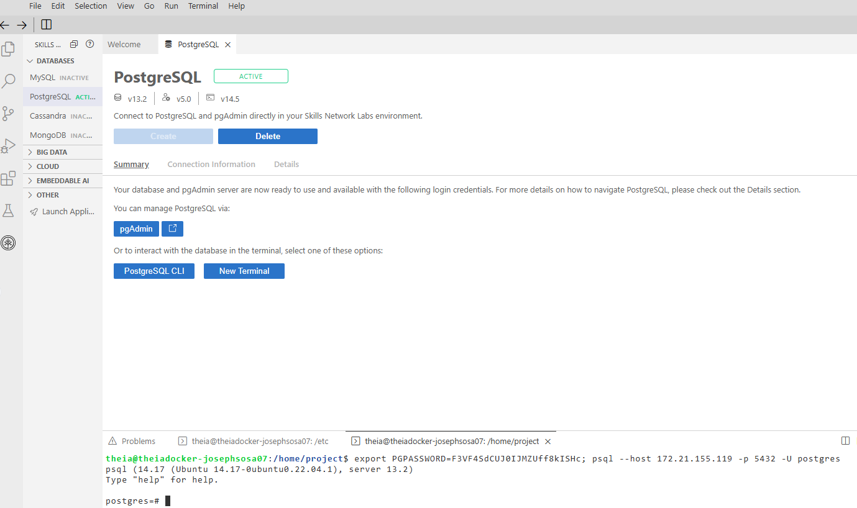

**Create a table** called users in the PostgreSQL database using PostgresSQL CLI. This table will hold the user account information.

The table users will have the following columns:

1. uname
2. uid
3. home
4. You will connect to template1 database which is already available by default. To connect to this database, run the following command at the ‘postgres=#’ prompt.

***\c template1***

**create table users(username varchar(50),userid int,homedirectory varchar(100));**

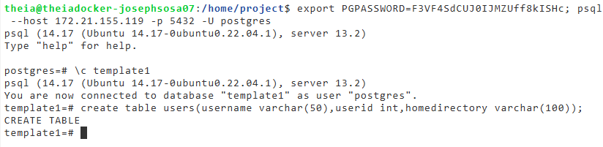

### **Exercise 5 - Loading data into a PostgreSQL table.**

In this exercise, you will create a shell script which does the following.

* Extract the user name, user id, and home directory path of each user account defined in the /etc/passwd file.
* Save the data into a comma separated (CSV) format.
* Load the data in the csv file into a table in PostgreSQL database.

Open a new Terminal and create a new shell script named csv2db.sh.

*touch csv2db.sh*

Open the file in the editor (nano csv2db.sh) and paste the following lines into the newly created file:

*# This script*

*# Extracts data from /etc/passwd file into a CSV file.*

*# The csv data file contains the user name, user id and*

*# home directory of each user account defined in /etc/passwd*

*# Transforms the text delimiter from ":" to ",".*

*# Loads the data from the CSV file into a table in PostgreSQL database.*

Save the file by pressing Ctrl+X, Y (then enter)

You need to add lines of code to the script that will extract user name (field 1), user id (field 3), and home directory path (field 6) from /etc/passwd file using the cut command.

Copy the following lines and paste them to the end of the script and save the file.

*# Extract phase*

*echo "Extracting data"*

*# Extract the columns 1 (user name), 2 (user id) and*

*# 6 (home directory path) from /etc/passwd*

*cut -d":" -f1,3,6 /etc/passwd*

Run the script.

***bash csv2db.sh***

Verify that the output contains the three fields, that you extracted:

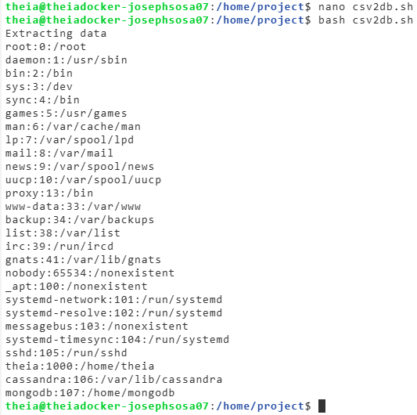

Change the script to redirect the extracted data into a file named extracted-data.txt

*Replace* the cut command at end of the script with the following command.

*cut -d":" -f1,3,6 /etc/passwd > extracted-data.txt*

Run the script.

***bash csv2db.sh***

***cat extracted-data.txt***

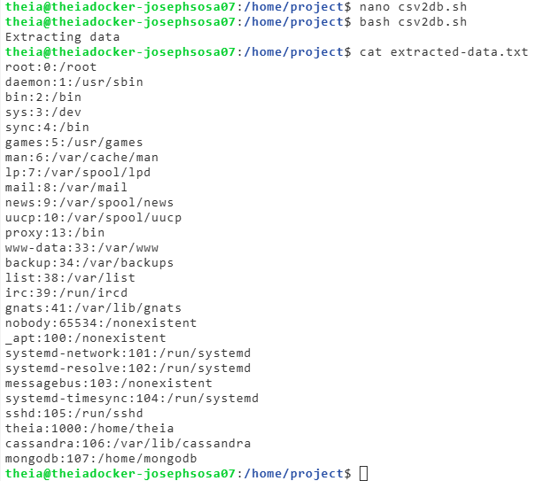

The extracted columns are separated by the original “:” delimiter. You need to convert this into a “,” delimited file. Add the below lines at the end of the script and save the file.

*# Transform phase*

*echo "Transforming data"*

*# read the extracted data and replace the colons with commas.*

*tr ":" "," < extracted-data.txt > transformed-data.csv*

Run the script.

***bash csv2db.sh***

**cat transformed-data.csv**

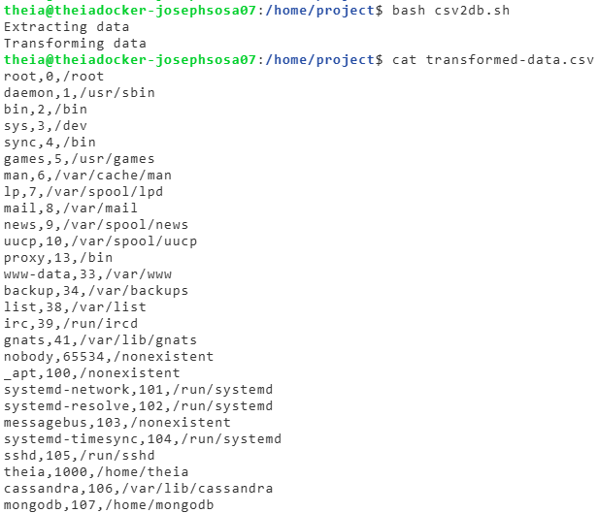

To load data from a shell script, you will use the psql client utility in a non-interactive manner. This is done by sending the database commands through a command pipeline to psql with the help of echo command.

PostgreSQL command to copy data from a CSV file to a table is COPY.

The basic structure of the command which we will use in our script is,

COPY table_name FROM 'filename' DELIMITERS 'delimiter_character' FORMAT;

Now, add the lines below to the end of the script ‘csv2db.sh’ and save the file.

*# Load phase*

*echo "Loading data"*

*# Set the PostgreSQL password environment variable.*

*# Replace <yourpassword> with your actual PostgreSQL password.*

*export PGPASSWORD=<yourpassword>;*

*# Send the instructions to connect to 'template1' and*

*# copy the file to the table 'users' through command pipeline.*

*echo "\c template1;\COPY users FROM '/home/project/transformed-data.csv' DELIMITERS ',' CSV;" | psql --username=postgres --host=postgres*

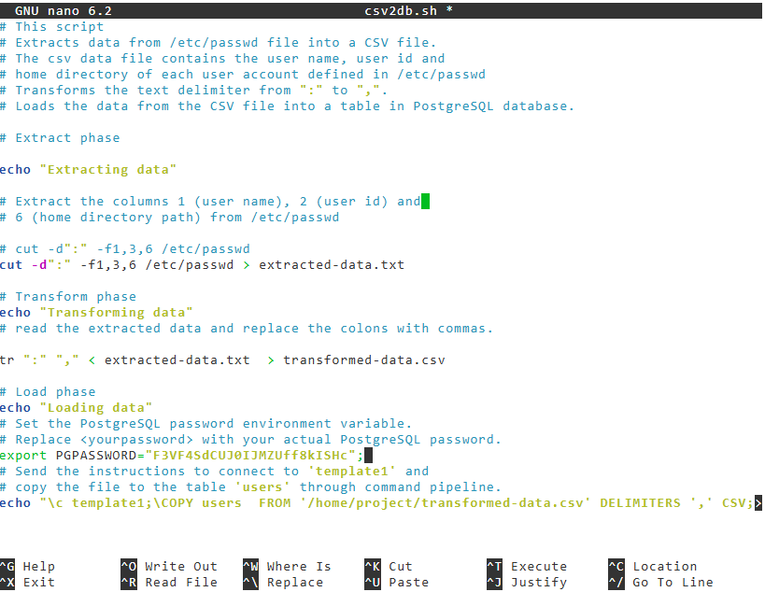

Run the script.

***bash csv2db.sh***

Now, add the line below to the end of the script 'csv2db.sh' and save the file.

*echo "SELECT * FROM users;" | psql --username=postgres --host=postgres template1*

Run the script.

***bash csv2db.sh***

Congratulations! You have created an ETL script using shell scripting.

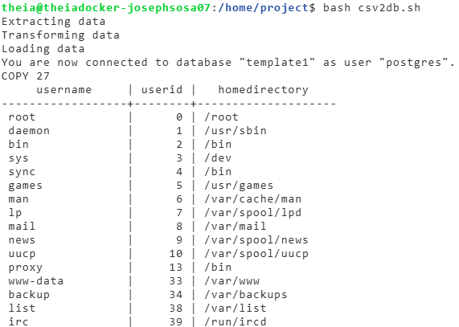

csv2db.sh:

*# This script*

*# Extracts data from /etc/passwd file into a CSV file.*

*# The csv data file contains the user name, user id and*

*# home directory of each user account defined in /etc/passwd*

*# Transforms the text delimiter from ":" to ",".*

*# Loads the data from the CSV file into a table in PostgreSQL database.*

*# Extract phase*

*echo "Extracting data"*

*# Extract the columns 1 (user name), 2 (user id) and*

*# 6 (home directory path) from /etc/passwd*

*# cut -d":" -f1,3,6 /etc/passwd*

*cut -d":" -f1,3,6 /etc/passwd > extracted-data.txt*

*# Transform phase*

*echo "Transforming data"*

*# read the extracted data and replace the colons with commas.*

*tr ":" "," < extracted-data.txt > transformed-data.csv*

*# Load phase*

*echo "Loading data"*

*# Set the PostgreSQL password environment variable.*

*# Replace <yourpassword> with your actual PostgreSQL password.*

*export PGPASSWORD="F3VF4SdCUJ0IJMZUff8kISHc";*

*# Send the instructions to connect to 'template1' and*

*# copy the file to the table 'users' through command pipeline.*

*echo "\c template1;\COPY users FROM '/home/project/transformed-data.csv' DELIMITERS ',' CSV;" | psql --username=postgres --host=postgres*

*echo "SELECT * FROM users;" | psql --username=postgres --host=postgres template1*

etc/passwd:

*root:x:0:0:root:/root:/bin/bash*

*daemon:x:1:1:daemon:/usr/sbin:/usr/sbin/nologin*

*bin:x:2:2:bin:/bin:/usr/sbin/nologin*

*sys:x:3:3:sys:/dev:/usr/sbin/nologin*

*sync:x:4:65534:sync:/bin:/bin/sync*

*games:x:5:60:games:/usr/games:/usr/sbin/nologin*

*man:x:6:12:man:/var/cache/man:/usr/sbin/nologin*

*lp:x:7:7:lp:/var/spool/lpd:/usr/sbin/nologin*

*mail:x:8:8:mail:/var/mail:/usr/sbin/nologin*

*news:x:9:9:news:/var/spool/news:/usr/sbin/nologin*

*uucp:x:10:10:uucp:/var/spool/uucp:/usr/sbin/nologin*

*proxy:x:13:13:proxy:/bin:/usr/sbin/nologin*

*www-data:x:33:33:www-data:/var/www:/usr/sbin/nologin*

*backup:x:34:34:backup:/var/backups:/usr/sbin/nologin*

*list:x:38:38:Mailing List Manager:/var/list:/usr/sbin/nologin*

*irc:x:39:39:ircd:/run/ircd:/usr/sbin/nologin*

*gnats:x:41:41:Gnats Bug-Reporting System (admin):/var/lib/gnats:/usr/sbin/nologin*

*nobody:x:65534:65534:nobody:/nonexistent:/usr/sbin/nologin*

*_apt:x:100:65534::/nonexistent:/usr/sbin/nologin*

*systemd-network:x:101:102:systemd Network Management,,,:/run/systemd:/usr/sbin/nologin*

*systemd-resolve:x:102:103:systemd Resolver,,,:/run/systemd:/usr/sbin/nologin*

*messagebus:x:103:105::/nonexistent:/usr/sbin/nologin*

*systemd-timesync:x:104:106:systemd Time Synchronization,,,:/run/systemd:/usr/sbin/nologin*

*sshd:x:105:65534::/run/sshd:/usr/sbin/nologin*

*theia:x:1000:1000:,,,:/home/theia:/bin/bash*

*cassandra:x:106:109:Cassandra database,,,:/var/lib/cassandra:/usr/sbin/nologin*

*mongodb:x:107:65534::/home/mongodb:/usr/sbin/nologin*

### **Practice exercises**

**Task 1. Copy the data in the file ‘web-server-access-log.txt.gz’ to the table ‘access_log’ in the PostgreSQL database ‘template1’.**

The file is available at the location : <https://cf-courses-data.s3.us.cloud-object-storage.appdomain.cloud/IBM-DB0250EN-SkillsNetwork/labs/Bash%20Scripting/ETL%20using%20shell%20scripting/web-server-access-log.txt.gz>

timestamp#latitude#longitude#visitorid#accessed_from_mobile#browser_code

2021-02-07 13:55:01#-16.23949# -132.90744#EDB35D96-3B72-7765-BD21-E955A87675B2#Yes#3

2020-07-16 15:36:41#-34.19226# -154.14365#7AEBC97C-7BD4-BA94-837A-8CDB3E880226#Yes#10

2021-09-13 05:50:33#33.04489# 41.19598#39712A91-BBC8-EF3E-F984-4BDBC47057E9#No#7

2020-07-13 16:23:35#-50.85272# -108.75484#06A1B090-9696-2173-2A3B-D2C45AA069D6#No#8

2022-02-11 02:09:34#-61.60674# 82.79596#DE2D0452-0772-8F82-5E97-0B7354F84DEC#No#3

2021-03-07 19:38:33#-35.13919# -171.89367#2E8AF9FB-711B-DABC-0B54-A583EA6CA5FC#No#2

2020-08-25 01:58:29#34.55951# -16.45943#F8FC0124-BE9E-2E57-645F-B015E16DD116#Yes#5

2021-09-05 08:16:37#-33.69251# -174.17613#03B8EE90-19BB-48DC-9990-005BF80B8846#Yes#1

2021-07-06 13:07:08#70.48283# -121.00994#48D703D3-A975-9665-61F3-5A95F5DB2D45#Yes#10

2020-11-13 17:27:03#-21.44983# -173.38079#89195F94-911D-3230-6298-BD9744F92059#Yes#10

2021-11-20 13:08:33#-86.75857# -45.29404#1FC81FC2-F834-58D0-9824-9746A6D324FA#No#5

2021-10-02 06:59:07#78.12541# -109.29209#3B710DEA-7F0A-9ABD-02CA-FEFCF9C2AC08#No#9

2021-09-17 08:16:02#87.85954# -0.57048#98EA0200-406F-51E6-4CA0-26D1EC317D19#Yes#6

2021-06-21 06:59:16#-1.71575# -60.02082#070415F9-2AAD-B246-29EA-470FEF936D3E#Yes#1

2021-05-16 13:53:54#74.79978# -47.88157#02744352-EE79-A24C-A92E-C569D226AF51#Yes#7

2021-10-20 17:30:46#25.41228# 107.46581#B607BCBF-A7CD-C7AD-3EF2-9E16C77972EE#Yes#4

2022-05-30 20:15:37#33.64084# -59.30366#BC25EDBE-4072-9207-B450-D642FAFE44C7#Yes#6

2021-04-15 00:18:50#8.64055# -5.03369#8A6B46C7-277B-BEFC-2CB3-603F4ADD30EC#Yes#6

2021-08-25 03:00:18#55.12455# 7.04004#194FDA02-F568-BF08-808A-B499ACA80D6D#No#3

2020-09-30 11:06:48#23.6149# -128.02395#764F8FEA-DFB7-4A6A-65B6-80164E6329D6#Yes#3

2021-08-25 23:59:36#-6.05372# -37.42406#4B3E0CC7-22E1-1141-77D3-8A62F4CA555F#No#1

2022-05-18 09:11:12#39.5568# -54.04188#BE5D4B8F-E200-5693-BDF4-F597E419FC03#Yes#6

2021-11-25 09:51:48#-65.63951# -123.44688#054CF800-A082-21EA-0682-18F19832C70E#No#9

2021-11-23 13:53:38#-13.51558# -153.86334#2FA3914A-476F-4011-8DBF-460105C34F61#Yes#4

2021-03-21 02:14:52#88.39536# 150.41886#A722AA34-EC37-3168-C7F1-569CAD44973B#No#5

2020-08-10 17:29:16#-55.90821# -150.63672#AE0F1894-B8C2-7953-4D0B-1237CCC8D4C2#No#6

2021-04-01 13:10:11#8.97437# -146.34376#EFD8051B-3E42-E09C-928F-206182B9C305#Yes#7

2022-03-15 15:08:42#42.02701# 108.77788#B2FBCD79-395C-5C3D-6EC0-377F25852D07#Yes#9

2021-04-19 20:31:02#-34.106# 60.91444#8A7206EF-8368-3BB2-54D3-CD44552E45C4#Yes#8

2021-05-13 20:24:11#15.18026# -49.54684#08F85212-D775-2328-7E48-774C52CBBB97#Yes#3

2021-12-16 17:21:06#-80.72449# -68.38024#18C91D9F-E453-5173-526E-0721973E574B#No#1

2022-03-04 07:00:31#-26.57181# -57.72631#6BAF2513-47D9-60A5-635E-29E88B476A9A#No#2

2020-12-25 12:24:02#6.39182# 178.16057#EFEE0A1D-C153-8382-CA93-C657F154E85C#No#2

2020-08-20 08:21:41#3.26614# -173.24904#77DE6458-1951-0E79-9019-F09977181433#Yes#9

2020-07-24 05:12:54#32.16941# 174.34977#707A2D9D-9275-F686-992F-2B0DE82A378C#Yes#6

2020-12-17 00:28:42#-29.04564# 155.31432#D81A6DF8-45D4-A40A-8204-BBD662C4188D#No#6

2021-07-31 01:54:50#-44.02212# -7.4646#BE5FA73D-4D97-EF7F-AD52-1BDE1B33AFF1#No#8

2021-11-01 04:01:16#33.51412# 132.70724#42DA4624-F74F-6F06-FF80-7165CC1041F6#Yes#1

2022-06-02 19:13:41#-80.55301# -161.1924#BE9D666D-2EF8-3315-6D97-214F858E725C#Yes#4

2020-10-15 09:33:34#-41.83723# -87.42219#EFF8A635-5929-FB66-AAB6-9EC4B50E5269#Yes#2

2021-11-29 23:47:18#-49.2888# 51.0428#06402D85-E8C0-FD75-F1DA-94671E31604D#No#9

2021-09-30 23:41:35#44.67288# -76.03852#435813FC-982D-ADDE-0181-DB1C463CE340#Yes#1

2020-08-13 02:50:10#-68.54324# 153.56803#CD7974D5-C906-D1CE-CA16-9E8F3D3DFB1A#Yes#8

2020-07-28 16:31:05#44.37974# 59.04558#A0287B58-B42A-84E5-DB34-FC7B3969F106#No#7

2021-01-30 03:41:47#-78.61912# 170.26037#6B4488A9-33AA-717A-54A2-674D4060CC8B#Yes#3

2021-04-28 18:11:25#42.01547# 6.29042#5C9414B4-79CE-4049-BAC2-98248B3A35D6#Yes#6

2020-07-24 05:53:20#-85.48522# -179.41636#BD9ACA31-A075-5E38-3B39-99FA4FC2FF54#No#4

2020-11-10 14:19:58#-16.02112# 95.27981#D9730EC4-D004-FFD7-1404-F8BD543ED6E4#Yes#10

2021-12-03 22:00:13#7.73954# 135.4707#97FFF648-E1D5-568E-9CF5-8EFF12CD07A8#Yes#2

2021-05-21 22:05:14#81.8616# 21.37654#5D3C06F9-A6C9-1680-2955-6BF66458109C#No#2

2021-08-28 02:49:32#-30.56843# -7.69715#32395EB6-77BE-0313-B3E2-3F68B2ABC6F6#No#1

2020-08-26 04:01:45#-60.07099# -149.02795#225A81B8-8C9F-97FF-1CF8-C7445DC78C3F#Yes#7

2020-09-19 04:19:43#82.2927# 69.4803#CF8B8FC5-0440-5159-F474-C79BBACA7BA5#No#2

2021-10-22 18:34:57#82.15002# 97.18394#E21AB622-8632-A134-15FD-21C310128B7A#No#7

2022-06-06 15:28:35#70.68899# -5.97012#B344B171-2502-3917-D9BD-CCF07BE76500#No#3

2021-07-30 19:14:01#5.2344# -64.51896#8FA41FE6-C1EF-E6F3-17D0-1CF0796F373E#No#6

2020-12-29 15:42:07#17.65548# -150.74154#2D89812D-4CB3-4F06-2E75-D6492CB1C8B4#Yes#8

2020-06-23 16:34:17#82.63509# 102.42151#43962CF5-FE5A-8981-74CB-E623019CCAE0#Yes#2

2022-03-01 08:54:23#45.72617# 111.92385#4EF343B7-D4B9-41E7-AAE8-F44BDCCA11B9#Yes#10

2021-01-17 11:54:47#-20.50576# 58.54271#A262F346-CF6F-05E8-65EA-15AFDE0F9E24#No#10

2022-05-31 12:09:23#-84.31857# 22.14532#A45DC07A-0B8C-A24D-FE7D-EE449A24DCF5#Yes#6

2020-08-10 19:34:23#7.77231# 90.55123#36EAE71C-2356-66CE-2E9A-F2A603E97336#No#6

2020-09-23 20:52:14#-27.58167# -102.41612#A6B67142-6086-1B52-1B9B-8D9020B9557B#Yes#1

2021-10-23 17:32:57#-8.47408# -53.38797#75062747-41E3-731D-4D91-053D2F68E496#No#6

2022-02-11 06:26:46#25.87501# -10.96135#F36B154C-EB22-EA73-2193-706160F12B85#No#3

2021-09-16 07:16:25#-75.15001# -58.90574#E80F5FDE-430A-35D4-9B6D-0BF7BD0CAC59#Yes#5

2022-02-18 00:10:44#-21.0956# -177.4213#C017977B-18FB-46D5-91F0-5FC7143AE390#Yes#8

2021-10-08 14:50:37#-4.0394# 38.73729#9177DB2F-96D7-3532-17FC-02CCE11700FA#No#3

2022-05-30 19:37:20#66.57967# -124.3124#B3761DBA-9C87-64E6-5463-1C4E14A6F808#No#4

2020-09-12 08:10:40#-89.68096# 129.53788#F1E34D7B-CAB6-2231-31F0-08358C009CFC#No#2

2021-04-08 00:12:59#34.64169# -138.80624#82255F65-79DD-77BB-7584-DA308501DA62#No#2

2020-12-30 19:48:16#-67.58431# 162.27673#D792AF85-0DE3-26CE-FE48-C188D291B6BC#Yes#8

2021-06-19 02:55:16#-61.58095# -106.78091#71DF9958-EDE1-1FE0-67E0-9D87E81325E9#No#1

2021-01-26 21:15:04#74.44465# -178.10722#8DB8FE5B-E809-F089-7730-E58E3FF58DB4#Yes#4

2022-04-10 16:33:35#-83.34055# -99.15553#4DA55AFC-2FA9-D279-650D-1715ACE6CE94#No#9

2021-04-23 08:03:47#71.70802# -38.93232#932B506E-4E95-178D-BC91-CB9BFD461B4C#Yes#3

2020-11-02 00:25:17#-61.05743# -17.89759#FE2C1C59-7EE3-DB72-68F0-1187AB2885B6#Yes#9

2022-06-15 04:11:22#-89.03855# -87.71342#0F9D54BB-A1B7-6477-E1B2-665C8D0F654C#No#8

2022-04-24 21:49:52#37.05041# -101.53113#8DB92116-EAE2-BA95-7DB2-685B92AECD57#Yes#8

2020-08-20 13:12:29#-88.15761# 76.91805#4C83591A-8709-E120-6317-5054804028A6#Yes#4

2022-04-30 20:44:04#-55.03054# 26.18992#62EADF17-61C3-B5BA-3026-D835138A2837#Yes#3

2021-10-29 00:44:03#42.01131# 19.44443#39610B6F-1510-5198-0812-B2D4D9D26327#No#9

2021-01-27 17:15:51#-4.90332# -37.1329#9A2EF930-ADB0-65BB-A008-3065E9E7FE73#No#10

2022-04-05 21:17:04#11.06151# -58.41535#FD9BCF7D-07EB-A8DA-3FA0-6C929C14CA23#Yes#4

2021-11-16 20:00:32#-67.65212# 156.8833#2EDC4AFC-7016-10BC-9C57-EFBFC86CBA6D#Yes#5

2021-04-14 18:48:02#-44.78967# -108.29017#5B567F1B-2ED6-2234-5750-C0F1388C6A66#No#3

2020-08-16 01:58:03#38.15676# -65.54833#72E77A69-3B9F-97A1-1D98-7E42683FF592#Yes#9

2021-06-27 07:48:03#-44.18974# -101.91488#48680F59-7834-184A-D837-066718B2A653#No#5

2022-01-05 01:25:38#-25.24748# 47.31703#E4CDF8B1-26E9-369F-F71C-3BD46385F1BC#No#5

2021-03-02 04:26:17#-59.08287# -97.05957#BFF21FBE-64AE-A1AC-D6A6-76745287EF10#Yes#9

2020-11-26 12:53:22#15.13321# -146.18016#1AEBC887-6CF3-7BE6-E0D5-174C704F084C#Yes#6

2022-01-03 13:56:21#87.03336# 87.95488#FB4C061B-81CB-E544-B7CF-6AC2FA1FFD7B#No#4

2021-10-27 09:11:52#-7.9537# 146.73432#CE5B9F98-3EDE-E6B0-54A8-8F6F430A9564#Yes#6

2022-03-16 02:03:01#-3.59497# 143.15895#849273F4-9496-7EC1-F385-F0E6F8B48746#Yes#6

2020-10-31 10:30:53#-1.26405# -118.46545#F58B5268-B383-3CE9-484F-89B108D8A779#No#9

2020-06-30 23:03:53#-43.81375# 179.54575#800485FF-CCCD-1284-8AC6-D3669599D303#Yes#9

2020-07-08 08:04:20#-39.11477# 88.94334#34AA9081-1ECC-7ED2-47B8-7D5083BCDB1B#No#7

2021-02-21 21:25:49#-44.3634# 31.75419#95D996BF-89B2-50B5-5537-7CF812364930#No#9

2020-12-20 01:08:23#-78.99085# -46.16735#EA1105C1-6A50-49D8-D73C-A26533FF53E0#No#9

2021-06-29 04:40:12#-0.01626# -80.18582#D0DB8B32-9BEB-4071-E58B-D2D8D8016C2D#No#1

The following are the columns and their data types in the file:

* + a. timestamp - TIMESTAMP
  + b. latitude - float
  + c. longitude - float
  + d. visitorid - char(37)
  + e. accessed_from_mobile - boolean
  + f. browser_code – int

The columns which we need to copy to the table are the first four columns: timestamp, latitude, longitude and visitorid.

*NOTE: The file comes with a header. So, use the ‘HEADER’ option in the ‘COPY’ command.*

**Solution:**

The problem may be solved by completing the following tasks:

1. Go to the SkillsNetwork Tools menu and start the Postgres SQL server if it is not already running.
2. Create a table named access_log to store the timestamp, latitude, longitude and visitorid.

***\c template1***

***create table access_log(timestamp TIMESTAMP, latitude FLOAT, longitude FLOAT, visitorid CHAR(37));***

**Task 3. Create a shell script named cp-access-log.sh and add commands**

Add the wget command to the script to download the file.

wget "https://cf-courses-data.s3.us.cloud-object-storage.appdomain.cloud/IBM-DB0250EN-SkillsNetwork/labs/Bash%20Scripting/ETL%20using%20shell%20scripting/web-server-access-log.txt.gz"

Use gunzip command to unzip the .gz file and extract the .txt file, to the script.

gunzip -f web-server-access-log.txt.gz

*The****-f****option of gunzip is to overwrite the file if it already exists.*

Extract timestamp, latitude, longitude and visitorid which are the first four fields from the file using the cut command.

The columns in the web-server-access-log.txt file is delimited by ‘#’.

Redirect the extracted data into a file named extracted-data.txt

**Transform the data into CSV format.**

The extracted columns are separated by the original “#” delimiter.

We need to convert this into a “,” delimited file.

**Load the data into the table access_log in PostgreSQL**

PostgreSQL command to copy data from a CSV file to a table is COPY.

The basic structure of the command is,

*COPY table_name FROM 'filename' DELIMITERS 'delimiter_character' FORMAT;*

The file comes with a header. So, use the ‘HEADER’ option in the ‘COPY’ command.

Invoke this command from the shellscript, by sending it as input to ‘psql’ filter command.

**cp-access-log.sh:**

# Download the file web-server-access-log.txt.gz:

wget "https://cf-courses-data.s3.us.cloud-object-storage.appdomain.cloud/IBM-DB0250EN-SkillsNetwork/labs/Bash%20Scripting/ETL%20using%20shell%20scripting/web-server-access-log.txt.gz"

# Unzip the file to extract the we-sever-access-log.txt file.

# The -f option of gunzip is to overwrite the file if it already exists

gunzip -f web-server-access-log.txt.gz

echo "Extracting data"

# Extract timestamp, latitude, longitude and visitorid which are the first four fields from the file using the cut command and Redirect the extracted data into a file named extracted-data.txt

cut -d"#" -f1-4 web-server-access-log.txt > extracted-data.txt

echo "Transforming data"

# Transform the data into CSV format, read the data and replace the # with commas.

tr "#" "," < extracted-data.txt > transformed-data.csv

echo "Loading data"

# Set the PostgreSQL password environment variable.

# Replace <yourpassword> with your actual PostgreSQL password.

export PGPASSWORD="F3VF4SdCUJ0IJMZUff8kISHc";

# Send the instructions to connect to 'template1' and copy the file to the table 'access_log' through command pipeline.

# Load the data into the table access_log in PostgreSQL

echo "\c template1;\COPY access_log FROM 'transformed-data.csv' DELIMITERS ',' CSV HEADER;" | psql --username=postgres --host=postgres

# Verify by querying the database

echo "SELECT * FROM access_log;" | psql --username=postgres --host=postgres template1

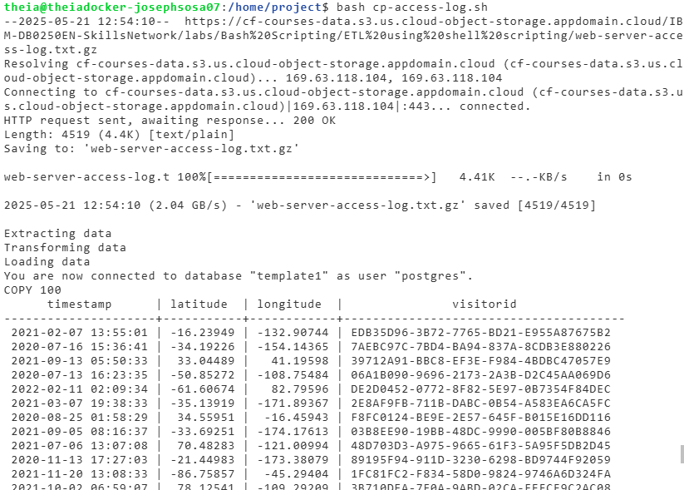

### Practice Quiz ETL using Shell Scripts

**Question 1. The transformation stage is where rules and processes are applied to the data for preparation of loading into target system. Which of the following transformations involves search performance?**

Aggregating

Sorting

Joining

Normalizing

**Question 2. The temperature reporting scenario that you are discovering in the video uses two APIs. What do these APIs do? (multiple answers)**

Keeps track of the temperature times

Extraction

Writes temp stats from log file

Load

**Question 3. There are many ETL tools available today. The modern enterprise grade ETL tools typically include common features. Which of the following common features of popular ETL tools helps with complex calculations?**

Transformation support

Drag-and-drop interface

Security and compliance

Automation

**Question 4. The ETL using Shell Scripts video shows a temperature reporting workflow with ten steps. Which step follows the extraction step in the workflow?**

Display dashboard with temp stats

Appends temp reading to log file

Schedule workflow to run each minute

Calculate temp stats from log file

**Question 5. The video creates an ETL shell script and names it ‘Temperature_ETL.sh’. A command is then used to turn it into what type of file?**

PY

BASH

CSV

Text

### Graded Quiz: ETL using Shell Scripts

**Question 1. Select the correct statement regarding Apache Airflow.**

Apache Airflow is a workflow orchestration tool.

Apache Airflow tasks can be expressed as Python, but not Bash.

Apache Airflow represents the workflow in DAGs, but not in code.

Apache Airflow is a well-known commercial tool.

**Correct**

Apache Airflow breaks down details of the workflow into tasks and dependencies.

**Question 2. What is the first stage of the ETL process?**

Extraction

Transformation

Cleaning

Loading

**Question 3. Select the correct statement regarding batch processing.**

Data is processed in batches, usually on a weekly schedule.

Batch processing triggers are rarely on demand.

When an event of interest occurs, such as an intruder alert, the interval would be periodic.

Batch processing intervals can be triggered by events.

**Question 4. Bash uses _____ to turn your file into a Bash shell script.**

crontab

shebang

loadstat

getstat

**Correct**

ETL pipelines can be built from basic Bash scripts. In the editor, type in the Bash shebang to turn your file into a Bash shell script.

**Question 5. SSIS, Amazon Redshift, IBM InfoSphere Information Server, and Oracle GoldenGate are examples of _____.**

Popular commercial ELT tools.

Popular open-source ELT tools

Popular commercial ETL tools.

Popular open-source ETL tools.

**Question 6. ETL pipelines are frequently used to integrate data from disparate and usually _____ systems within the enterprise.**

batched

siloed

simultaneous

aggregating

**Correct**

The systems within the enterprise are usually separate, that is siloed.

**Question 7. Select the correct statement regarding ETL workflows as data pipelines.**

Data is fed through a data pipeline in large packets.

Overall accuracy of the ETL workflow has been a more important requirement than speed.

With conventional ETL pipelines data is processed in real time.

Bottlenecks within the pipeline can often be handled by anonymizing slower tasks.

**Correct**

Accuracy is valued over speed, although efficiency is usually an important factor in minimizing resource costs.

**Question 8. Which of these transformations is correctly described?**

Data Structuring: Fixing any errors or missing values

Cleaning: merging disparate data sources

Sorting: selecting only what is needed

Normalizing: Converting data to common units

**Correct**

Cleaning is fixing errors. Sorting is order the data for searching. Data structuring is converting one data format to another.

**Question 9. Which of these is NOT an example of a system in the data load phase?**

An Excel spreadsheet

A comma separated file

A scanned medical document

A data warehouse

**Correct**

A scanned medical document is an example of data in the Extraction phase.

**Question 10. ETL jobs can be run on a schedule using _____.**

loadstat

crontab

shebang

getstat

### **Introduction to Data Pipelines**

What is a pipeline

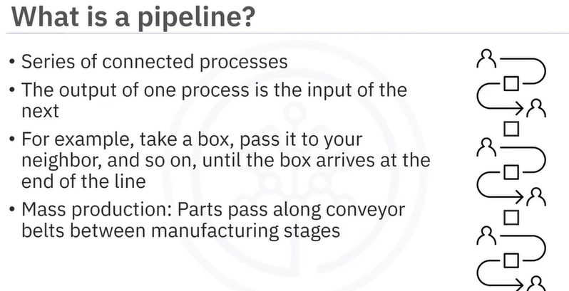

The purpose of a data pipeline is to move data from one place or form to another.

A data pipeline is a system which extracts data and passes it along to optional transformation stages for final loading. This includes low-level hardware architectures, but our focus here is on data pipelines as architectures driven by software processes such as commands, programs, and processing threads.

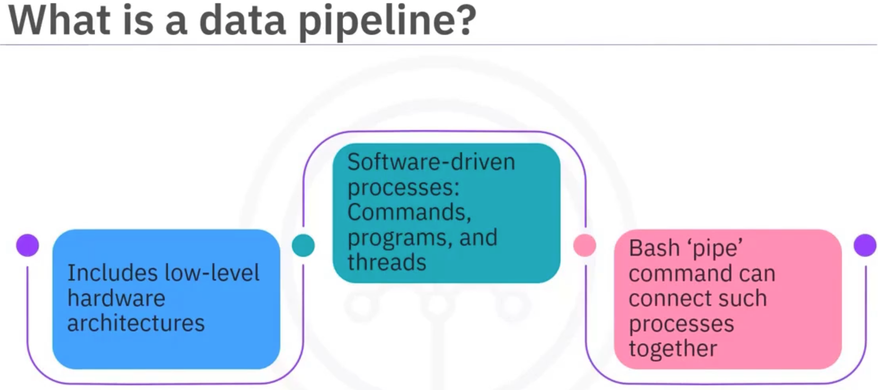

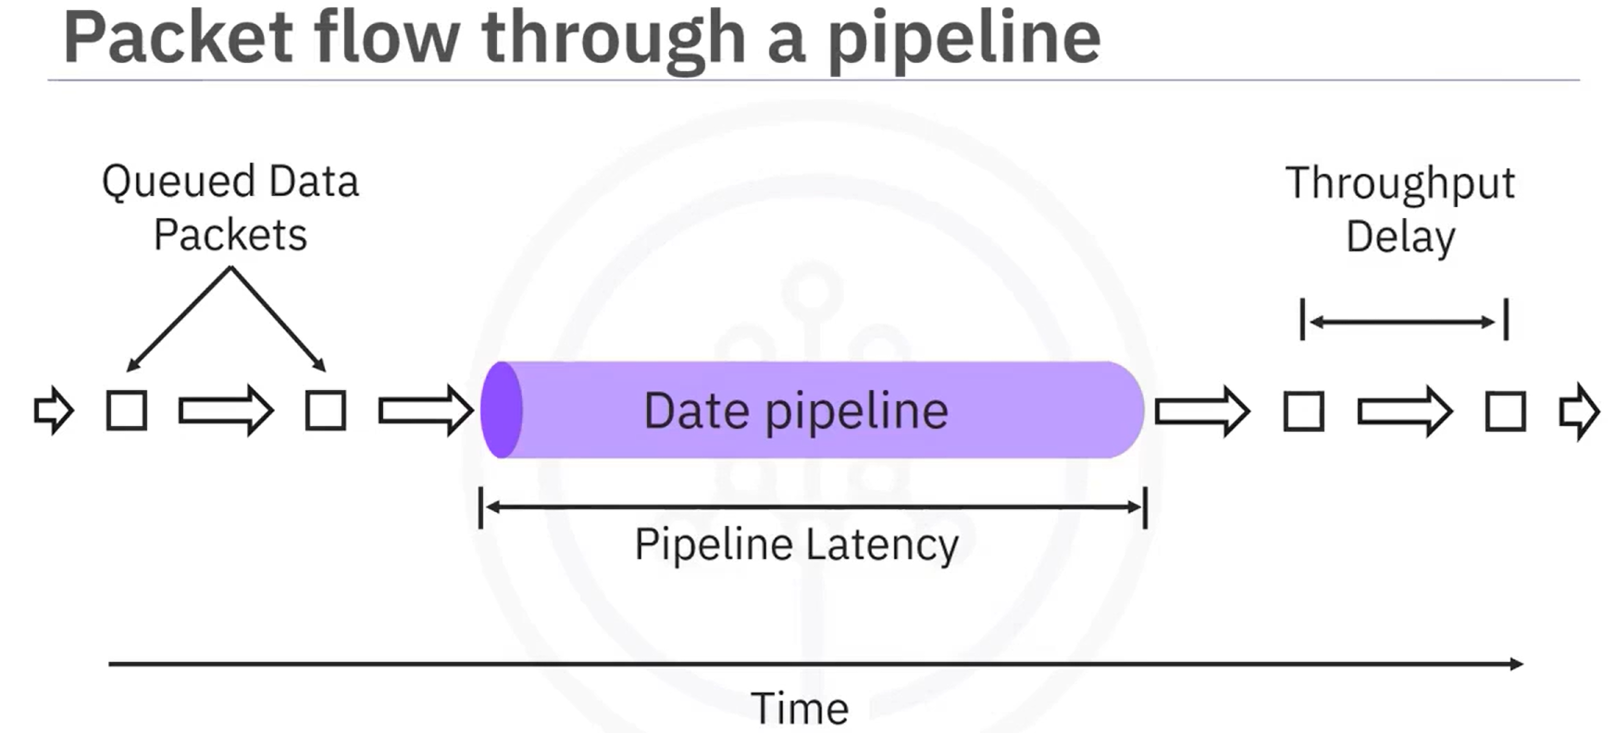

Here we have data packets queued for ingestion to the pipeline. The length of the data pipeline represents the time it takes for a single packet to traverse the pipeline. The arrows between packets represent the throughput delays or the times between successive packet arrivals. You have just been introduced to two key performance considerations regarding data pipelines. The first is latency, which is the total time it takes for a single packet of data to pass through the pipeline.

Equivalently, latency is the sum of the individual time spent during each processing stage within the pipeline. Thus, overall latency is limited by the slowest process in the pipeline. For example, no matter how fast your internet service is, the time it takes to load a web page will be decided by the server speed.

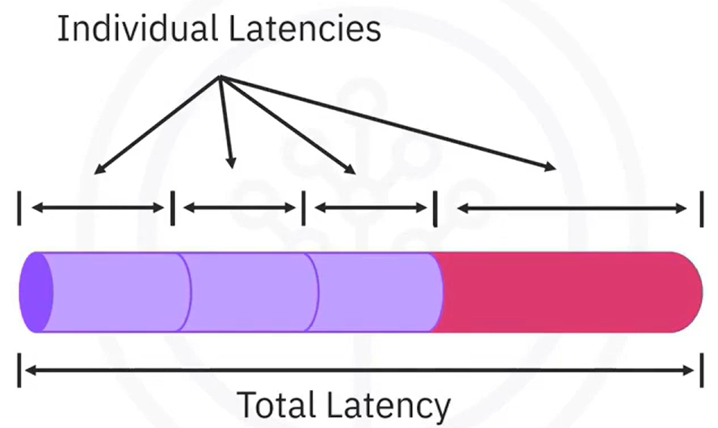

The second performance consideration is called throughput. It refers to how much data can be fed through the pipeline per unit of time. Processing larger packets per unit of time increases throughput.

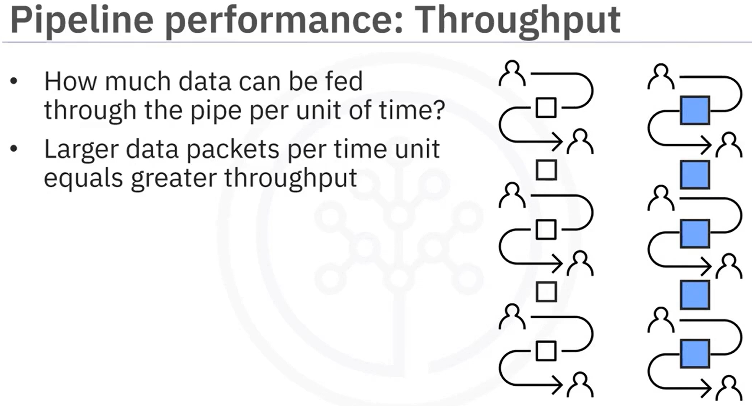

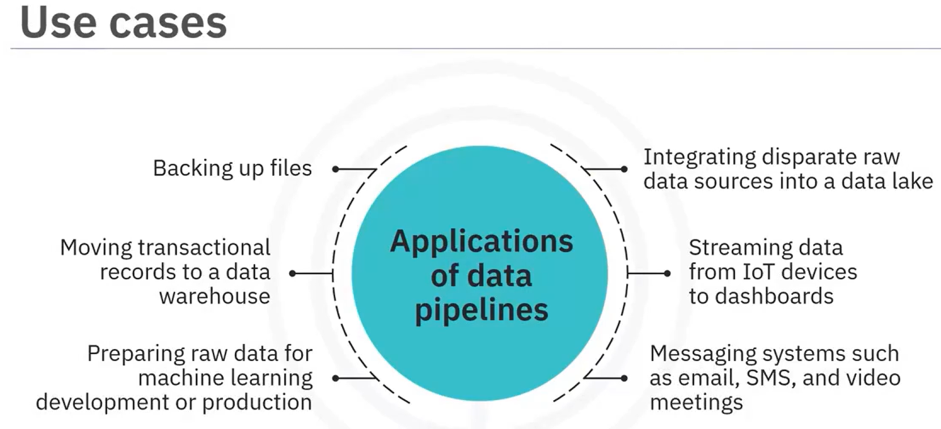

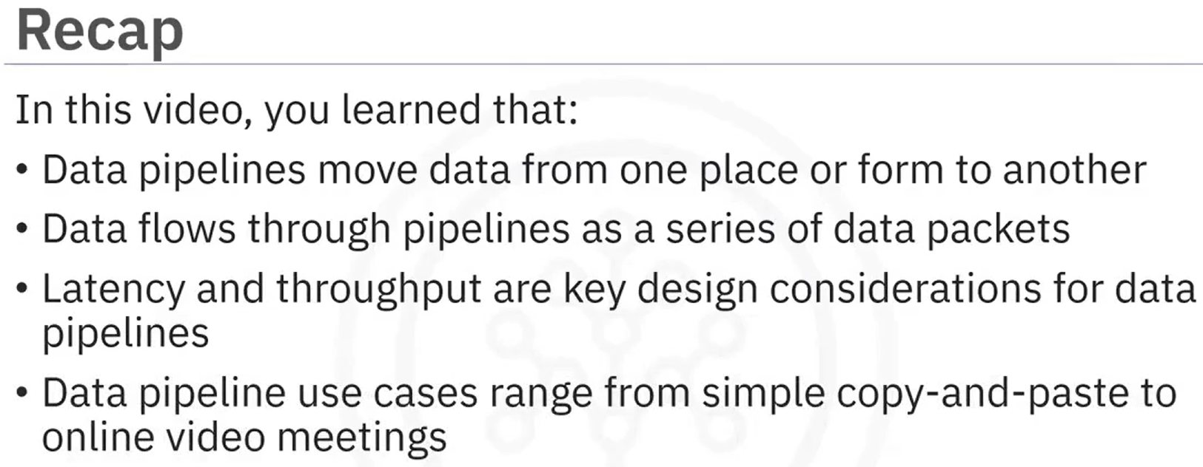

### **Key Data Pipeline Processes**

Data pipeline processes typically have the following stages in common. Extraction of data from one or more data sources, ingestion of the extracted data into the pipeline, optional data transformation stages within the pipeline and final loading of the data into a destination facility, a mechanism for scheduling or triggering jobs to run, monitoring the entire workflow, and maintenance and optimization as required to keep the pipeline up and running smoothly.

Stages of data pipeline processes:

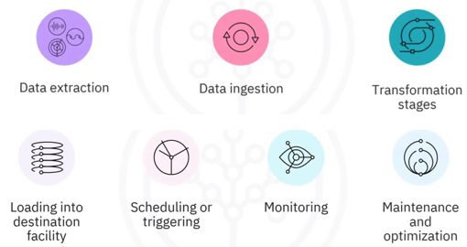

**Pipeline monitoring considerations.**

Some key monitoring considerations include:

* Latency, or the time it takes for data packets to flow through the pipeline.
* Throughput demand, the volume of data passing through the pipeline over time.
* Errors and failures caused by factors such as network overloading and failures at the source or destination systems.
* Utilization rate, or how fully the pipelines resources are being utilized, which affects cost.
* And a system for logging events and alerting administrators when failures occur.

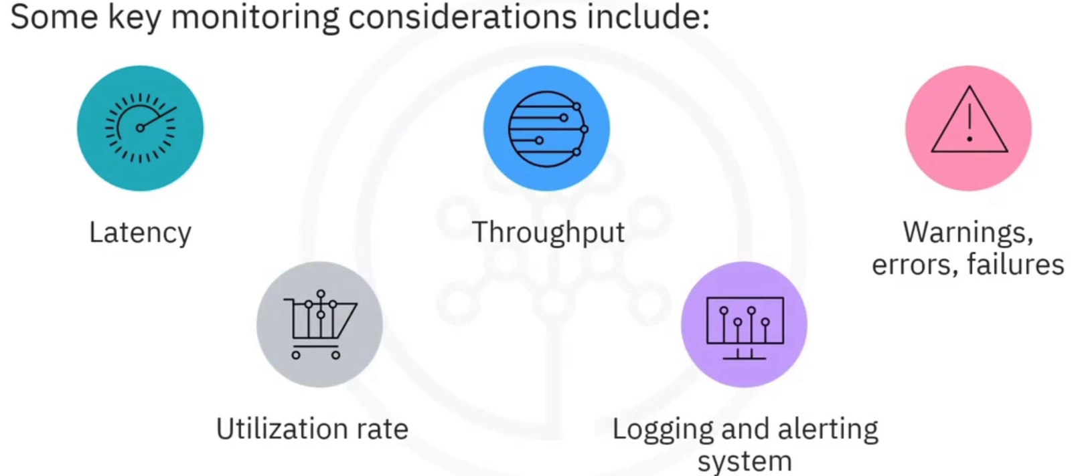 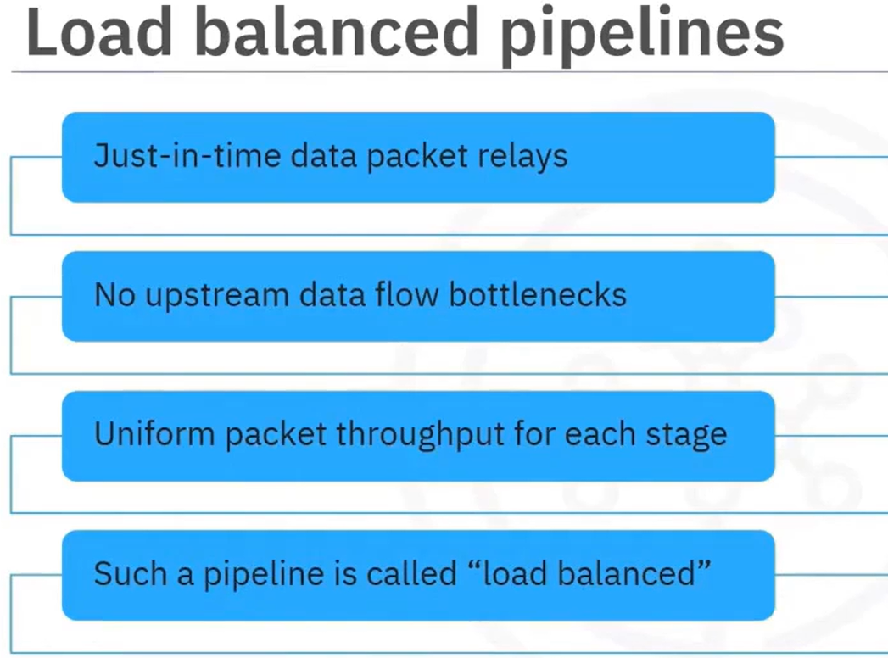

Suppose your pipeline has a bottleneck in one of its stages, such as the longer red section here, which has more latency than the other stages in the pipeline. If it's possible to parallelize that stage, for example by splitting the data into two concurrent stages like this, then you can reduce this stage's latency. There will be a little overhead in managing the parallelization and recombination of the output back into the pipeline, but the overall latency will be reduced. Due to the time and cost considerations, pipelines are rarely perfectly load balanced. This means there will almost always be stages which are bottlenecks in the data flow. If such a stage can be parallelized, then it can be sped up to align better with the flow rate. A simple way to parallelize a process is to replicate it on multiple CPUs cores or threads and distribute data packets as they arrive in an alternating fashion amongst the replicated channels. Pipelines that incorporate parallelism are referred to as being dynamic or nonlinear, as opposed to static, which applies to serial pipelines.

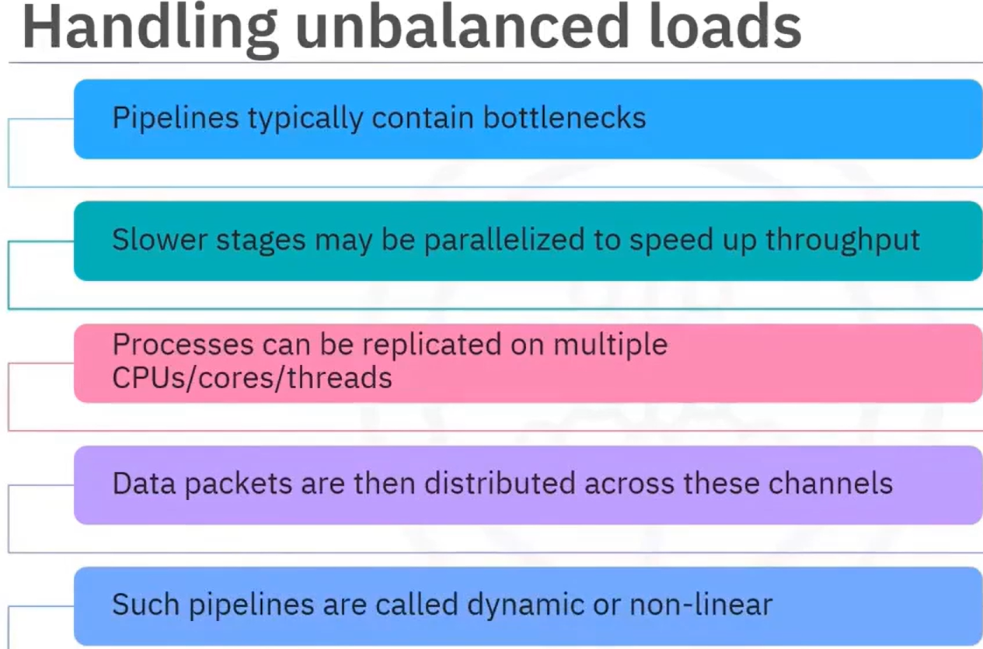

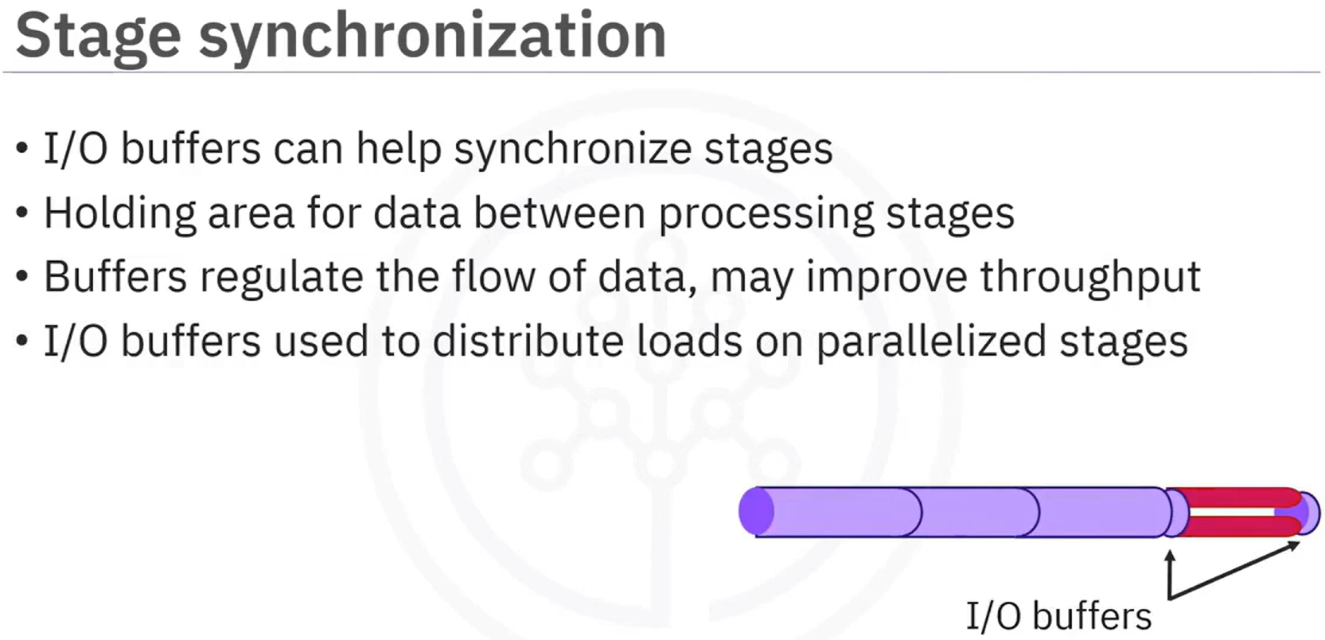 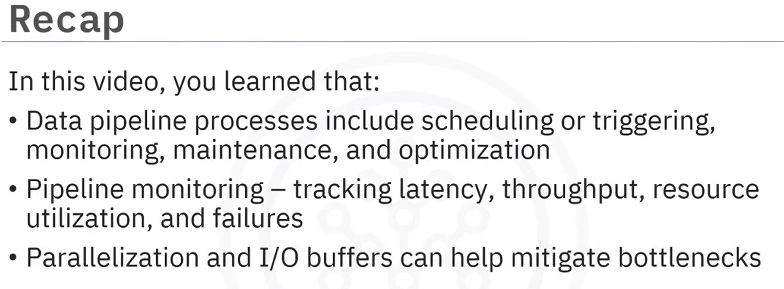

### **Batch versus Streaming Data Pipeline Use Cases**

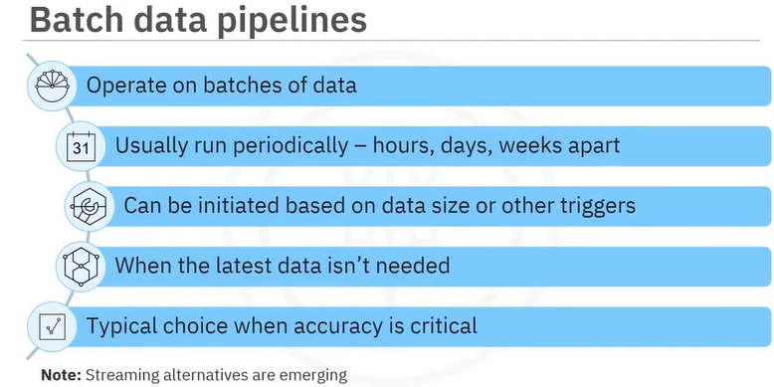 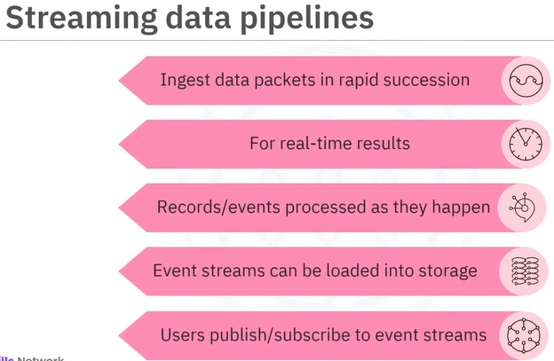

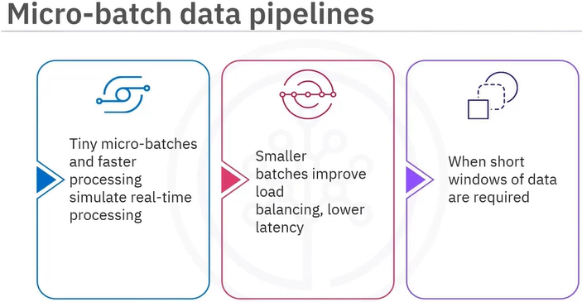

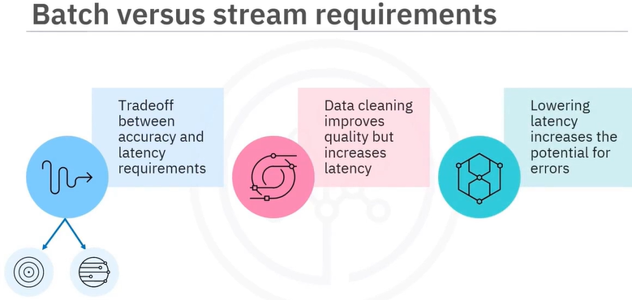

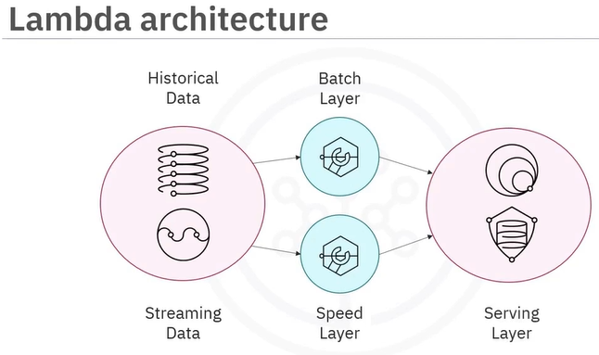 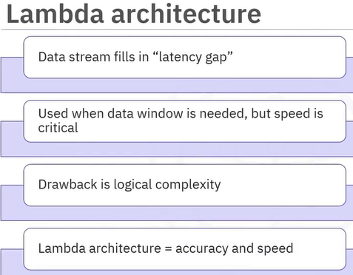

Example use cases for batch data pipelines include periodic data backups and transaction history loading, processing of customer orders and billing, data modeling on slowly varying data, mid- to long-range sales forecasting and weather forecasting, analysis of historical data and diagnostic medical image processing. Use cases for streaming data pipelines are on the rise and include cases such as watching movies and listening to music or podcasts, social media feeds and sentiment analysis, fraud detection, user behavior analysis, and targeted advertising, stock market trading, real-time product pricing, and recommender systems.

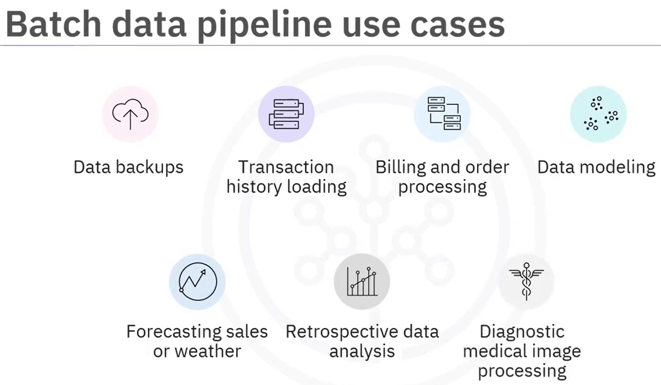

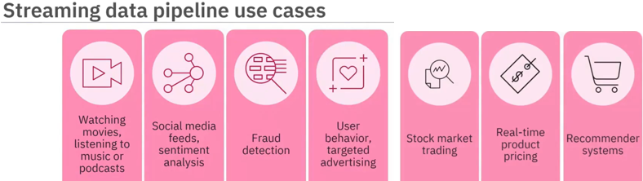

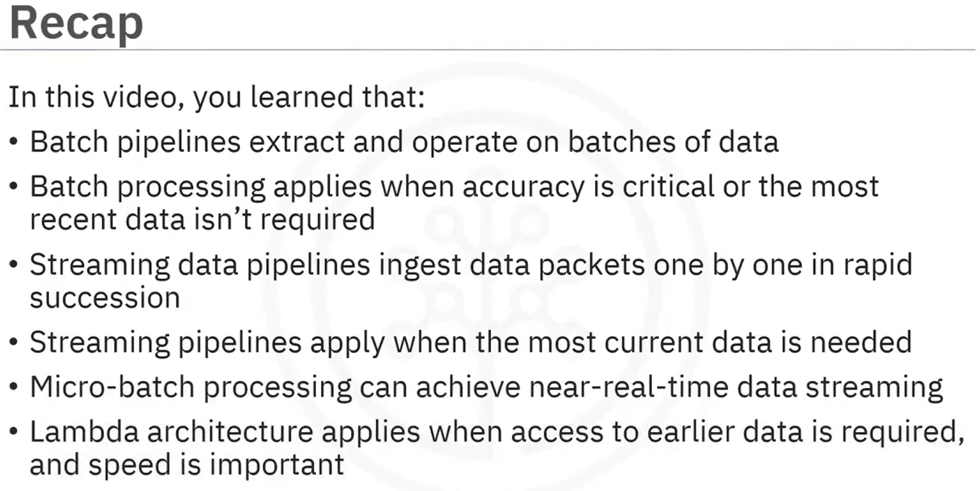

### **Data Pipeline Tools and Technologies**

**Features of modern pipeline tools:**

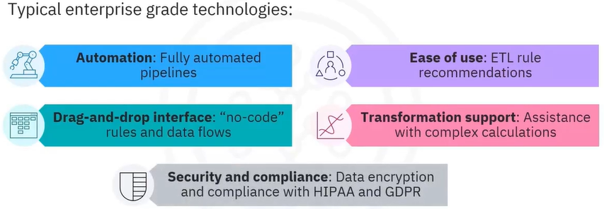

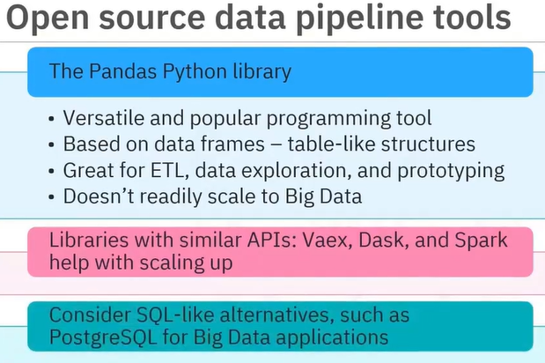 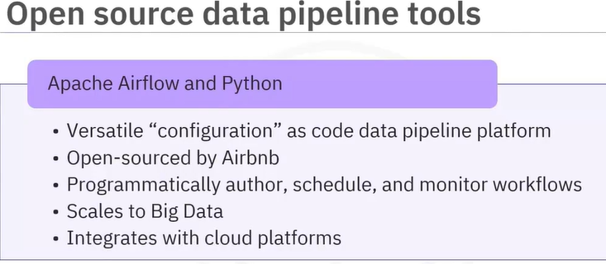

Apache Airflow integrates with most Cloud platforms, including AWS, IBM, Google Cloud, and Microsoft Azure.

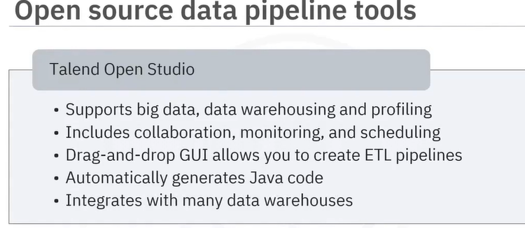

Talend Open Studio connects to many data warehouses such as Google Sheets, RDBMS, IBM, DB2, and Oracle.

**Enterprise data pipeline tools:**

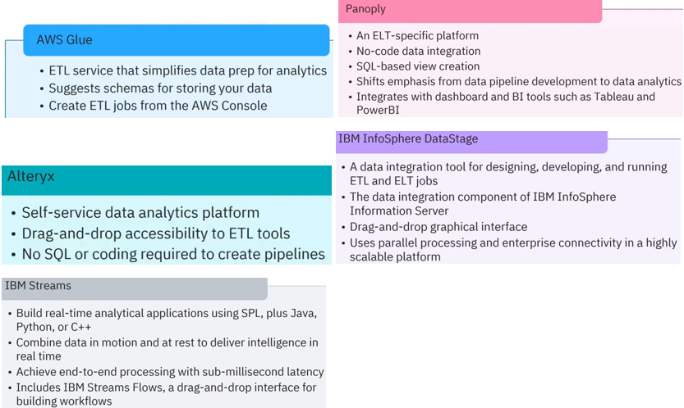

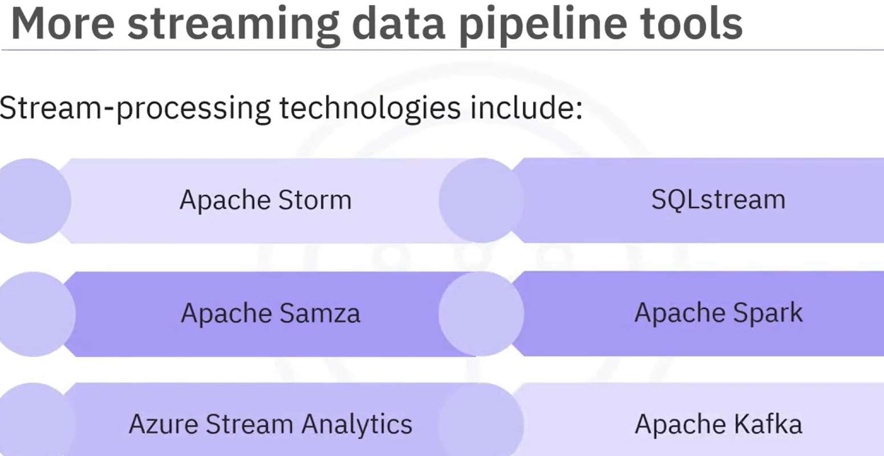 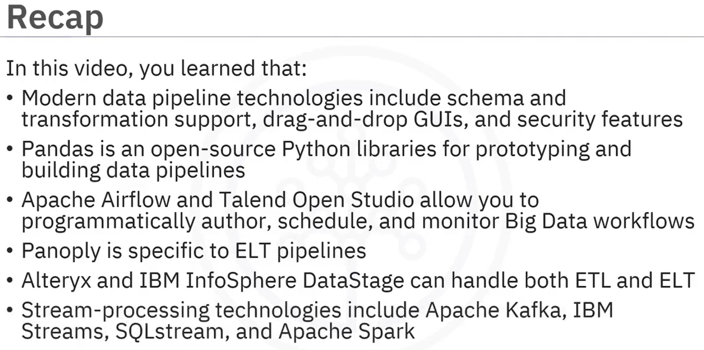

### Interactivity: Differentiate between Batch Processing and Stream Processing

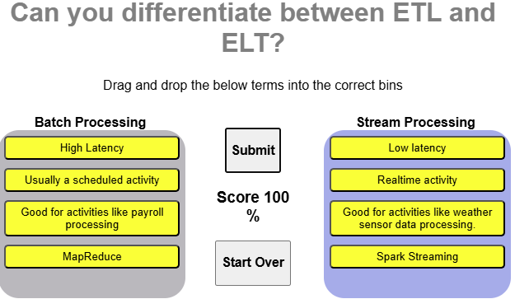

MapReduce (Hadoop). Procesamiento **por lotes** (batch)

Spark Streaming. Procesamiento en **micro-batches** (casi en tiempo real)

### Summary

* Data pipelines move data from one place, or form, to another
* Data flows through pipelines as a series of data packets
* Latency and throughput are key design considerations for data pipelines
* Data pipeline processes include scheduling or triggering, monitoring, maintenance, and optimization
* Parallelization and I/O buffers can help mitigate bottlenecks
* Batch pipelines extract and operate on batches of data
* Batch processing applies when accuracy is critical, or the most recent data isn’t required
* Streaming data pipelines ingest data packets one-by-one in rapid succession
* Streaming pipelines apply when the most current data is needed
* Examples of streaming data pipelines use cases, such as social media feeds, fraud detection, and real-time product pricing
* Modern data pipeline technologies include schema and transformation support, drag-and-drop GUIs, and security features
* Stream-processing technologies include Apache Kafka, IBM Streams, and SQLStream

### Practice Quiz: An Introduction to Data Pipelines

**Question 1. What is the main purpose of a data pipeline?**

Data container

Loading

Move data from one place or form to another

Storage

**Question 2. There are always stages that are bottlenecks in the data flow of pipelines. Which of the following is a simple way to load balance pipelines?**

Serialize

Buffers

Queues

Parallelize

**Question 3. Which of the following data pipeline tools is specific to ELT?**

AWS Glue

Panoply

Alteryx

Talend Open Studio

**Question 4. Which of the following is the main reason to use Lambda architecture instead of Micro-batch, Streaming, or Batch data pipelines?**

Help with load balancing

Accuracy is critical

Records are processed immediately

Access to earlier data and speed is important

**Question 5. Which of the following data pipeline processes keep the pipeline running smoothly?**

Monitoring

Scheduling and Triggering

Maintenance and Optimization

Ingestion

### Graded Quiz: An Introduction to Data Pipelines

**Question 1. Which of the following data pipelines corresponds with the fraud detection use case?**

Streaming data pipeline

Lambda architectures

Micro-batch data pipeline

Batch data pipeline

**Question 2. Batch data pipelines usually run periodically on fixed schedules. Which of the following is another method to run these?**

Flags

Manually

Error occurrence

Triggers

**Correct**

Correct, Batch processes typically operate periodically on a fixed schedule – ranging from hours to weeks apart. They can also be initiated based on triggers, such as when the data accumulating at the source reaches a certain size.

**Question 3. Pipelines that incorporate parallelism are referred to as being_____ ?**

Dynamic or non-linear

Aligned

Static

Linear

**Question 4. Which streaming data pipeline tool allows you to build applications using the Streams Processing Language (SPL)?**

IBM Streams

Apache Spark

SQLstream

Apache Samza

**Correct**

Correct, IBM Streams lets you build real-time analytical applications using the Streams Processing Language, or SPL, plus Java, Python, or C++.

**Question 5. Which of the following data pipeline use cases is the simplest?**

Transactional record movement

File backup

Send/receive messages

Raw data preparation

**Correct**

Correct, the simplest pipeline is one which has no transformations and is used to copy data from one location to another, as in file backups.

**Question 6. Which of the following common features of modern ETL and ELT products is known as "no-code"?**

Fully automated

Data crawling

Drag-and-drop

Security

**Question 7. How does data flow through pipelines?**

Software processes

Processing threads

Files

Data packets

**Question 8. Which of the following pipeline monitoring considerations affects the amount of data that passes through the pipeline over time?**

Logging and alerting system

Throughput

Utilization

Latency

**Correct**

Correct, this is the volume of data passing through the pipeline over time.

**Question 9. Latency is the total time it takes for a single packet of data to pass through the pipeline. Which of the following limits latency?**

Slowest process

Bad data

Small data packets

Data leak

**Correct**

Correct, latency is limited by the slowest process in the pipeline.

**Question 10. Micro-batch data pipelines decrease the batch size. Which of the following do micro-batch pipelines increase?**

Storage

Latency

Batch process refresh rate

Simple transformation

**Correct**

Correct, the refresh rate of individual batch processes is increased to achieve near-real-time processing.